AIRCRAFT, March, 1977, pages 28-

RAAF disappointment led to HISTORIC FFLIGHT
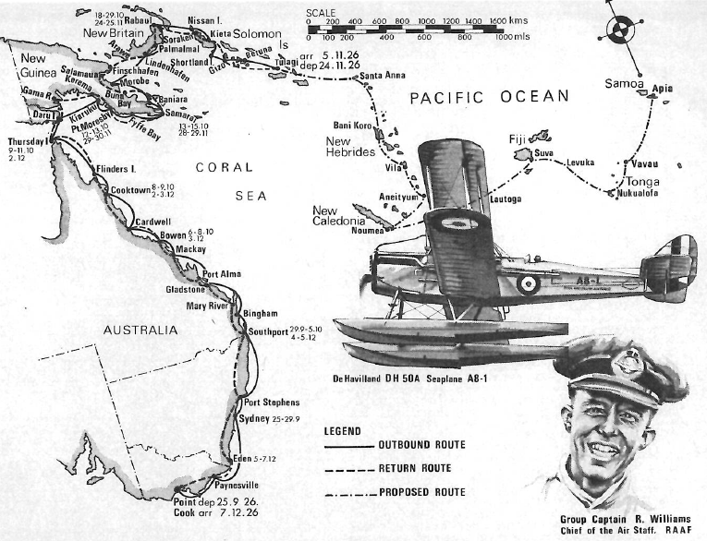
Strategic air planning in the Royal Australian Air Force has its genesis in a 16,000 kilometres (10,000 miles)defence survey Right made over 50 years ago by the Chief of the Air Staff, Group Captain Richard Williams, DSO, OBE. Group Captain Keith Isaacs, AFC,ARAeS, RAAF (Retd.), recalls the vicissitudes of this historic event, which Was also the first RAAF overseas flight, and the first flight by an Australian based aircraft to areas beyond Australasian territories.
A David Hammond impression for AIRCRAFT of Group Captain R. Williams and the route he followed along east coast of Australia and through 'Papua New Guinea, New Britain, and the Solomon Islands to Tulagi, and return. Also shown is the original proposed route Of 27,300 kilometres ( 17,000 miles) to Apia, Samoa, and return, which was cancelled by ministerial direction.

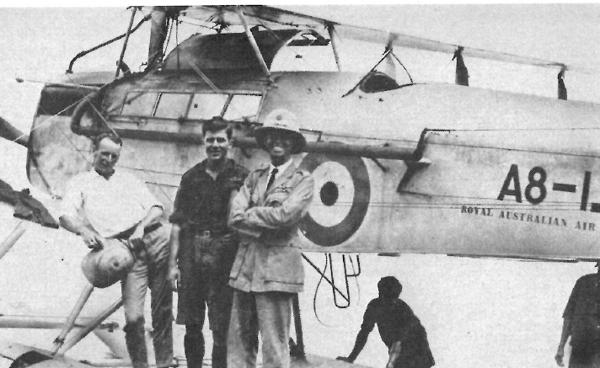
ON JUNE 24, 1924, the Prime Minister, Mr S. M. Bruce, announced the first major rearmament programme for Australia since the end of the 1914-18 war. At the time, the Royal Australian Navy was regarded as the nation's first line of defence and most of the defence expenditure went to the purchase of new warships for strategic operations in the Pacific and Indian Oceans. Orders were placed for two long-range cruisers, HMASs Australia and Canberra, an aircraft carrier, HMAS Albatross (see First of the Line, AIRCRAFT, July, 1976), and two ocean going submarines, HMASs Otway and Oxley.
The Royal Australian Air Force which had purchased only six locally built . Avro 504K trainers since it was formed on March 31, 1921 received barely enough money to acquire three non-combat aircraft. Although orders were placed in 1925 for nine aircraft, six of these machines (the Supermarine Seagull Ill amphibians, A9-I to 6) were financed from the Navy vote to form a fleet cooperation flight. The RAAF's meagre acquisitions were two de Havilland DH.60 Cirrus Moth trainers, AT-I and 2, and a sole de Havilland DH.50A transport aircraft, A8-1, "for conveyance of the Governor-General and other government officials."
Disappointed at not being able to acquire long range flying boats for strategic patrols the Chief of the Air Staff, Group Captain R. Williams, decided to do the next best thing. He proposed making a survey flight of the British possessions in the Pacific, by flying some 27 ,300 kilometres (17,000 miles) to Samoa and return. The object of the flight "was to gain knowledge of the geography and flying conditions of the islands in the Pacific adjacent to Australia for air defence purposes." The route for this pioneering journey was through the islands of Papua New Guinea, Solomon, New Hebrides, New Caledonia, Fiji, and Samoa.
Long open sea distances, and lack of landing fields at the island destinations, dictated that a marine-type aircraft would be required for the flight. The CAS had three versions of maritime aircraft available for consideration the Fairey illD seaplane, the Supermarine Seagull Ill amphibian, and the de Havilland DH.50A which had been ordered with an interchangeable wheel and float undercarriage. The ageing IllDs were past their prime as they had been in service since 1921, and the Seagulls were committed to their naval cooperation tasks. So it came about that the DH.50A, in seaplane configuration, was selected for the flight. Furthermore, the 240hp Siddeley puma engine of the DH.50A with its low compression permitted the use of ordinary motor spirit, which was the only kind of fuel available at most of the intended refuelling locations.
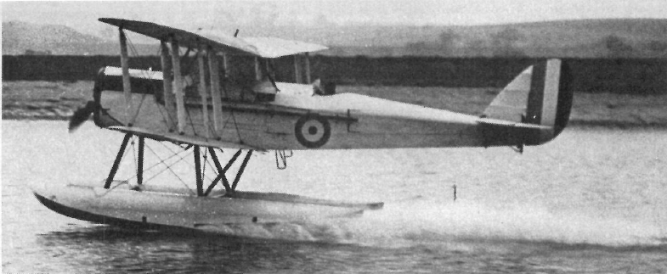
The RAAF's DH.50A (c-n 134) was the tenth such aircraft built by the de Havilland Aircraft company Ltd. at Stag Lane Aerodrome, Edgware, Middlesex. "The other day at Stag Lane I was shown the DH.50A which is being built for the Commonwealth Air Board," reported AIRCRAFT's British correspondent, Major F. A. de V. Robertson, in April, 1926. "It looks very comfortable. The front seat in the cabin is removable, providing additional space for uniform cases, as well as an ordinary permanent luggage compartment. There are all the refinements, such as wireless, navigation lights, and parachutes. At least my guide seemed to think that there was a parachute for the pilot, doubtless with the object that if anything went really wrong he would be able to stand his court-martial

The DH.50A (c-n 134) taking off from River Medway near the Shorts' works at Rochester U.K. on its maiden seaplane flight in April 1926. The number A8-I was applied on arrival at Point Cook (Flight photograph) .

After the DH.50A was flight tested as a landplane, it was delivered to the Short Brothers Ltd. works at Rochester. There it was fitted with specially built duralumin twin floats, and flight tested as a seaplane from the River Medway. The aircraft was formally accepted for the RAAF on May 4, 1926, by the Commonwealth Liaison Oficer at the Air Ministry, Wing Commander S. J. Goble, and it was then shipped to Australia.
In August the DH.50A was assembled and tested as a landplane at RAAF Point Cook. At the same time the aircraft serial number, A8-1, was applied to the fuselage together with the legend, Royal Australian Air Force in small letters under the serial number for national identification at overseas ports of call while showing the flag.
During the same month Group Captain Williams received ministerial approval to use the aircraft as a seaplane for his forthcoming survey flight. The twin floats were fitted in September, and the CAS personally tested the seaplane on the 11th. It was then omcially announced that Group Captain Richard Williams, DSO, OBE, would be in charge cf the flight, with Flight Lieutenant Ivor Ewing McIntyre, CBE, AFC, as co-pilot and Flight Sergeant Leslie Joseph Trist as engineer. Because of the infrequent reporting points along the isolated route, it was decided not to carry a wireless operator. Consequently, 54kg (120 1b) of wireless equipment was removed and replaced with extra spare parts.
It was originally planned to depart on Friday, September 24, but a rough sea off Point Cook prevented the heavily laden seaplane from lifting off, and the departure was postponed for 24 hours. The Group Captain R. Williams second attempt was successful and the flight commenced at 0550 hours on the 25th. When the seaplane alighted at Paynesville, on the Gippsland Lakes in Victoria, to take on fuel, it was found that a small external leak had developed in the engine's water jacket. Nevertheless, the flight resumed at 1019 hours, and McIntyre landed in Rose Bay at 1540 hours, amidst the normal Saturday afternoon's conglomeration of pleasure craft on Sydney Harbor.
The seaplane was beached and, after an inspection of the leaking water jacket, it was decided to change the engine. The replacement Puma one of those supplied with the 1920 Imperial Gift equipment was obtained from Wing Commander L. J. Wackett's RAAF Experimental Section at Randwick. The engine change took three days, and the aircraft was ready to resume the flight on the 29th.
Departure time was set for 1000 hours, but McIntyre had to taxi the seaplane around for 35 minutes to stir up the smooth water surface to enable the aircraft to lift off. En route to Southport, Queensland, the aircraft refuelled at Port Stephens, and the flight then continued for four and a half hours against head-winds. Shortly before 1700 hours, when the fliers were within 9.7 kilometres (six miles) of Southport, the engine suddenly failed and McIntyre had to make an emergency landing in the open sea. It was found that a split-pin had been dislodged from the pilot's throttle control, and the fault was quickly remedied. High seas, with waves of 3-3.6m (10-12ft) were running and it was impossible to take off again, so McIntyre set about taxiing some eight kilometres (five miles) to Southport. The failing light, and the spray from the breakers, prevented the crew from locating the entrance to Southport, and McIntyre had to skilfully taxi ashore through a high breaking surf. The firing of a Very light brought assistance from the local cinema which was screening a silent epic. A party of 50 men dragged the machine across the sand-dunes to a lagoon where McIntyre taxied to a secure position in front of the Grand Hotel. Over seven hours had elapsed since the forced landing, and the exhausted crew collapsed into their beds during the early hours of the 30th.
An inspection carried out later in the morning revealed that the propeller had been badly damaged, and would have to be replaced. The only suitable propeller available was in the process of being built at the RAAF Experimental Section. Work on this propeller was hurriedly completed, and it arrived at Southport on October 4. It was fitted and tested immediately, and the seaplane was readied for departure on the following morning.
Meanwhile, the unfortunate incidents that had occurred to the seaplane since the fliers left Point Cook were being adversely reported in the newspapers. In fact, the Acting Minister for Defence, Mr C. W. C. Marr, was even called upon to cancel the flight. In the official report of the flight subsequently compiled by the CAS the Group Captain commented that "up to this time there had been a certain amount of Press criticism regarding the flight. When the leak developed in the water jacket in Sydney it was said that this was to have been expected, as the Puma engine, which was being used, usually developed internal trouble in the water jacket. The one developed on the flight was external. When the machine failed to get off after the forced landing at Southport, it was assumed, in the Press, that the reason was due to the limited performance of the machine. This was not so, for no seaplane could possibly have taken off from the sea running on that day."
The DH.50A departed from Southport at 0620 hours, October 5, refuelled at Bingham three hours later, and arrived at Gladstone at 1320 hours. On the 6th the fliers completed the next stage to Bowen, after landing at Mackay for fuel. The DH.50A was met and escorted into Bowen by one of the Seagull Ill amphibians of No 101 (Fleet Co-operation) Flight which was stationed in the area. The CAS remained at Bowen on the 7th, inspected the flight, and flew out to the section of the Great Barrier Reef that was being photographed by the Seagull crews. On October 8 the fliers reached Cooktown after refuelling at Cardwell, and the next day they flew to Thursday Island via Flinders Island.
At this point the DH.50A was about to become the first locally based aircraft to fly out of Australia. AIRCRAFT later commented that "after an exchange of telegrams with Defence Headquarters on the advisability of pushing ahead or returning to Melbourne, the flight was resumed to Papua just about this time a section of the Press was printing a lot of sheer nonsense about the difficulties encountered during the early stages of the flight. The then Minister for Defence was in England. His Acting Minister seems to have lent a credulous ear to those who wanted to have the flight stopped at Thursday Island and for a while there was some real danger of {heir representations being acted upon. Actually, the flight didn't begin to grow interesting until after leaving Thursday Island, for most of the places called at in the Pacific had never previously been visited by aircraft."
The fliers departed from Thursday Island on Monday, October 11, at 0817 hours and, after flying 209 kilometres (130 miles) across the Torres Strait, alighted at Daru Island, Papua. On the 12th they proceeded along the Fly River Delta, and across the top of the Gulf of Papua where the aircraft flew into its first tropical storm. After landing at Kiaruku, Yule Island, for fuel, the DH.50A eventually reached Port Moresby at 1720 hours. The following day's flight took the party to London Mission Station at Fyffe Bay for fuel, and on to Samaria where the aircraft touched down at 1515 hours. Torrential rain held up the fliers for 24 hours at Samaria where they were guests of the Bishop of New Guinea.
The flight continued on the 15th to Morobe, via Baniara. While crossing Milne Bay the aircraft ran into a heavy tropical storm which caused the engine to lose power. McIntyre turned back to evade the downpour and, when the engine subsequently picked up, he flew around the storm area. Morobe was the first landing made in the Mandated Territory, and the party found a welcoming wire awaiting them from the Administrator at Rabaul.
"The next day was hot and muggy without a breath of wind," Group Captain Williams recounted in his report. "The surface of the sea was like glass, and a ground swell was coming in from the ocean. We had planned to fly to Lindenhafen, but under these conditions it was impossible to get off with the necessary load to make it in one flight."
On October 17, however, conditions were much better and the seaplane was flown across the Huon Gulf, via Fami Islands, direct to Cape Bulli on the south coast of New Britain, and reached Lindenhafen at 1500 hours. The following day the fliers reached Rabaul at 1622 hours after a 362 kilometres (225 miles) flight from Lindenhafen. Further telegrams were then exchanged with the Defence Department, culminating in authority being received to proceed beyond Rabaul "Continuation of flight to Tulagi approved. Acting Minister desires impress no undue risks should be taken and feels flight should not proceed beyond Solomon Islands."

Typical of the many PNG departure scenes, this picture shows the crew being taken out to A8-I and natives swimming around the floats note the repaired rudder with the red, white and blue stripes partly obliterated. Gp. Capt Williams later flew A8-I as a landplane around Australia surveying aerodromes for defence requirements. Accompanied by two RAAF DH-9s, he covered almost 20,917 kilometres (13,000 miles) between July and September, 1927.
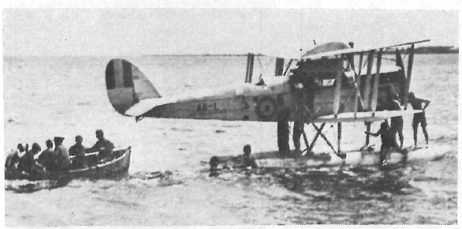

While awaiting approval to continue the flight,an opportunity was taken to top-overhaul the engine. This work was completed on October 26, when a test flight was carried out. Unfortunately, the Custom's launch drifted into the tail of the machine, and severely damaged the rudder. It took two days to repair this damage. At daylight on the 29th, A8-1 was flight tested with the two-bladed propeller that had been used since leaving Southport. The DH.50A was then temporarily fitted with a four-bladed propeller originally designed for the Wackett Widgeon I amphibian. The Widgeon's propeller had been positioned at Rabaul so that it could be tested in the warmer latitudes. "This propeller, however, caused considerable vibration and It was found to be out Of truth." reported Group Captain Williams. "It was not tested in the air." The normal propeller was refitted and the fliers departed from Rabaul at 1050 hours on the same morning. After flying across New Ireland and clearing the east coast, the aircraft ran into rainstorms Defore arriving at Nissan Island. An inspection at Nissan revealed that an internal leak had developed in the water jacket of No 2 cylinder. Temporary adjustments were made and the flight continued on October 30 to Kieta.
An attempt was made the following morning to fly to Gizo, but a landing had to be made at Shortland Island because of heavy rain and bad weather along the rest of the route. The weather, in fact, deteriorated so much that the aircraft was grounded for the following two days during which time it was found that the engine sump had cracked. Nevertheless, a successful take off was achieved on November 3, and the fliers arrived at Gizo at 1020 hours.
A second take off for Maravo Lagoon had to be abandoned when the engine missed, and vibrated badly under full power. The seaplane was beached, and it was found that No 6 cylinder had also developed a leak in the water jacket. Again, temporary adjustments were made Nos 2 and 6 cylinders were freed of water through the plug holes, the engine was warmed up, and clean plugs were then inserted in the faulty cylinders just before take off and the fliers reached Maravo Lagoon, and stayed overnight at Betuna. Departing next morning the party flew 241 kilometres (150 miles) to Tulagl and alighted at 1320 hours, November 5. The seaplane was beached immediately at the Burns Philps island, Makambo.
As Tulagi had now been made the terminal point of the survey, a new engine was requested from Sydney. The only Puma available was the engine that had developed the leaking water jacket on the flight from Point Cook to Sydney, and had since been repaired at the Experimental Section. It was shipped aboard ss Mataram from Sydney on November 12, and arrived at Tulagi on the 21st. The engine was immediately installed, and A8-1 was flight tested on the afternoon of the 23rd.

The return flight to Point Cook commenced on November 24 when 1,242 kilometres (772 miles) were covered in 7 hours 55 minutes with landings at Gizo, Kieta, Soraken, and Rabaul where the seaplane alighted just before dark. The next morning the fliers departed at 0650 hours, but impenetrable storms caused them to return to Rabaul after 30 minutes flying. A second departure was made at 1330 hours, and Lindenhafen was reached at 1710 hours after a refuelling stop at Palmalmal "a plantation in Jacquinot Bay . managed by an Australian who had little communication with the outside world, and who inquired as to the winner of the Melbourne Cup and the result of the last Test match."
The following morning bad weather delayed the take off until 1253 hours, and the fliers arrived at Arawe at 1400 hours. Continuous heavy rain then kept the aircraft grounded until 0900 hours the next morning. After leaving Arawe the crew flew to Finschhafen, Salamaua, and arrived at Buna Bay after travelling 470 kilometres (292 miles) in four hours flying time. On November 28, 515 kilometres (320 miles) were covered between Buna and Samaria, with a refuelling stop at Baniara. The following day's flight was curtailed by local rainstorms and ended at Port Moresby after refuelling at Abau. Rain again hampered progress on the 30th, and the fliers could only travel to Kerema, some 228 kilometres (142 miles) from Port Moresby.
The weather was still bad on December I when the fliers took off, at 0812 hours, for Daru. About 90 minutes out from Kerema the aircraft encountered a storm of such magnitude that McIntyre was forced to turn back and he alighted on the Gama River. The crew tied the seaplane to the river's bank, and took shelter in a native hut with five of the local inhabitants. Efforts to speak to the natives in Pidgin English were unsuccessful and, after the rain had cleared, McIntyre took off again and reached Daru at 1500 hours. The Resident Magistrate was most interested in the behaviour of the natives at Gama River, because they had not seen a white man for two and a half years. On that occasion two village constables were appointed but, when they arrived in their respective villages, they were promptly disposed of by the local inhabitants !
The next day's flight of 853 kilometres (530 miles) brought the party back to Australia when, after refuelling at Thursday and Flinders Islands, the aircraft alighted at Cooktown. On the 3rd the seaplane flew to Cardwell, Bowen, Mackay, and Port Alma, completing 1,143 kilometres (710 miles) in 9 hours 15 minutes. The following day's run comprised 595 kilometres (370 miles) from Port Alma to Southport, via Gladstone and the Mary River.
On Sunday, December 5, the aircraft made good time from Southport to Port Stephens where McIntyre alighted to refuel. The CAS's original intention was to fly to Sydney but, with such fine weather and favourable winds, he decided to bypass the harbor and proceed to Eden. Unbeknown to Group Captain Williams, a reception had been arranged at Sydney and a formation of RAAF aircraft flew out to escort the CAS into Rose Bay. When the seaplane failed to appear, fears for the safety of the crew began to grow until a sighting report of the seaplane was received from Jervis Bay.
Bad weather kept the fliers at Eden on the 6th the first and only day on which a flight was not made since leaving the Solomon Islands. The next morning McIntyre took off from Eden on the final stage of the survey flight. After refuelling at Paynesville, Melbourne was sighted just before 1500 hours. Two Fairey IllD seaplanes had been launched to escort the DH.50A into its home base but they failed to make contact. Three SE.5A fighters, and nine Avro 504K trainers, then took on and accompanied the CAS's aircraft to Point Cook, where the seaplane alighted at 1512 hours, at the end of its epic journey.
The Pacific islands survey flight of 16,000 kilometres (10,000 miles) occurred between September 25 and December 7, 1926, and 126 hours 4 minutes were flown on 31 flying days. Of the 23 areas visited in Papua, the Mandated Territory of New Guinea, and the British Solomon Islands Protectorate 20 of the districts had never seen an aircraft. remaining three were visited by a Vought UO-I floatplane from an American battleship which called at the islands on the return voyage from Australia after the visit of the United States Fleet in 1925.
At the conclusion of Group Captain Williams' history making flight, the Prime Minister, Mr Bruce then in London cabled "Congratulations on splendid achievement in your flight of ten thousand miles. You have demonstrated the wonderful possibilities of aviation, not only in linking Australia more closely with outlying portions of the Empire in Pacific, but also in defence of Australia and adjoining possessions."
In retrospect, the flight would have been even more successful but for the misfortunes encountered with the seaplane's temperamental Puma engine. The fast return flight of 8,121 kilometres (5,046 miles) in 13 flying days demonstrated what could be achieved when the engine functioned normally and, of course, the original intention of surveying 27,300 kilometres (17,000 miles) to Samoa would have been accomplished but for the engine malfunctions.
In recognition of the fliers pioneering and surveying achievements, Group Captain Williams was awarded a CBE, Plight Lieutenant McIntyre a Bar to his AFC, and Flight Sergeant Trist an AFM, in the 1927 Birthday Honours. McIntyre also received the Oswald Watt Gold Plaque for 1926 ("for achieving the most brilliant performance in the air during the year in the Commonwealth of Australia . . .") having previously been awarded the same medal in 1924 for the RAAF Fairey IllD seaplane flight around Australia (see AIRCRAFT, May 1974). In his History of Australian Aviation (The Hawthorn Press, 1960), Stanley Brogden relates that "the flight . . was hailed at the time in England as another triumph for British aircraft."
Of more importance than the honours and tributes. however, was the omcial report of the flight compiled in 1927 by the CAS. This comprehensive defence assessment was submitted to the Minister for Defence on May 31. The report formed the basis for strategic air planning in the Pacific islands adjacent to Australia until the advent of the 1939-45 War; when, of course, the PNG-New IrelandSolomons theatre of war became an Achilles' heel in the Japanese plan to conquer the Pacific. There is no doubt that of all the flights made by Air Marshal Sir Richard Williams, RBE, CB, DSO, the most significant was his 1926 strategic survey.

