Street  and are is suited your banker want, the purfor how long | C0"tiuued from page  Williams Was on the War "outer." He became a ••desk•s man first as A.O.C., R.A.A.F. Overseas H.Q. in London, and then as Australian air representative at ashington.  Williams is still lean, trim, and with soldier-square shoulders: That physical fitness is a slight indication of how hard a blow it was for him •to be kept out of the fighting war.  He must feel sore, too, at the shabby deal Air Force had in Australia's family of fighting Services,

C.B., R.A.A.F.,
called  "Dick!"  THE FIRST OF A NEW  DEALING WITH MEN  IN AUSTRALIAN  By NORMAN ELLISON  Marshal R. D. ("Dicky")  C.B.E., D.S.O., former and now Director-General Civil Aviation.  the hectic periods of World Vat the Middle East, airmen became aware of a human phenomenon. Major R. Williams, D.S.O., C.O. Sqüadron, Australian Flying Corps. him different from his fellows fact that he, an Australian, skipunit renowned for its dash, and known for red-blooded delight in games, did not drink, smoke, swcar, or that.  and men called him ^{t C}Dicky" That homely nickname was of the affection they bore him. ever addressed him as such.  years lacer, he is Ait Marshal C.B., C.B.E., D.S.o., DirectorCivil Aviation. Nov, scores of of airmen know him—as "Dick y" But still there is •no proof that ever used his nickname in his not fear or awe that is the one just doesn't take even so liberty with Williams.  the basic reason is his irftenSe the protective armour of digpropriety he has donned. But also always been a stickler foc the milithing; and almost throughout his he has worn uniform.  Australian, he took up soldierprofession- He graduated as an the first military school under the scheme for the building up of a Australian Army.  the first flying school began Cook, Lieut. Williams (A. and I. one of the first four trainees do the course. He won his wings.  the first numerically complete flying unit sailed for Egypt, with | 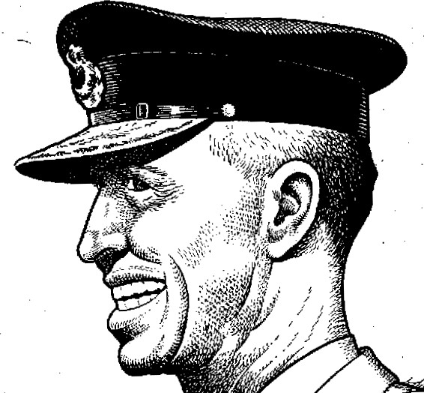  him  SERIES  OF  WHO  AVIATION.  Williams,  C.A.S.,  of  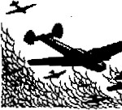  Capt. Williams O-C. of a Flight. It was Without instruction in gunnery, bombing, armament and photography. In fact, many of che men had not even seen an aeroplane!  That was the nucleus of what was to become No. 1 Squadron, Australian Flying Corps. No. 1 vas to develop such men as Ross Smith, Hudson Fysh (founder of Qantas) , Murray Jones (who put Australian de Havillands into splendid flight) , ^{t}'Pard" Mustar (who in New Guinea gave thc world a new technique in air-freightins), McNamara (Austral; a's only air V.C. of World war 1).  It was to earn from the R.A.F, comman-  der in the Middle East this magnificent compliment: "No. I Australian Squadron is  one of the best squadrons in the Air Force the results that have been achieved by thg R.A.F. in the Middle East have been, to a very marked degree, due to the work of No. SqOadron."  The man who built up and commanded this ace unit had a magnificent organising ability, and pluck and powers of leader ship. And his memory was prodigious. It is said of him that he knows every man who ever served with him by name, rank, regimental previous unit and qualification.  When the Australian Flying Corps was demobifised, Colonel Williams remained a | 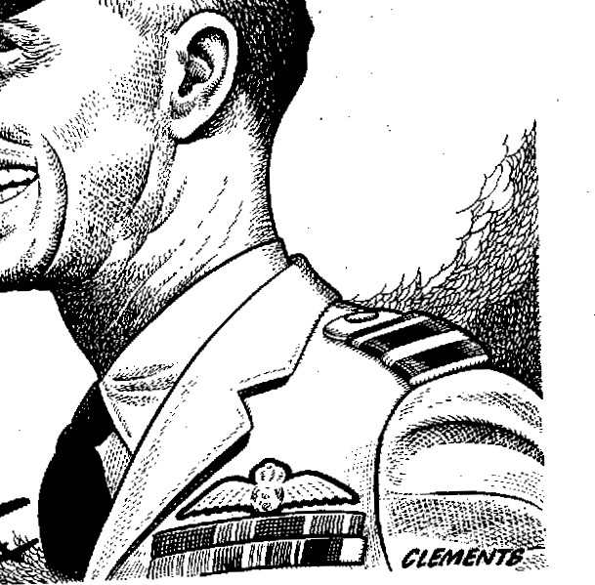  soldier of the air. He went into the Australian Air Corps—as its senior oßcer. That post he retained when, a quarter of a century ago, the R.A.A.F. Was established.  As Chief of the Air Staff, Williams had a stormy passage. His was chc Cinderella of the fighting services. As a legacy of R.F.C. versus R.N.AS., there was within his service a faction fight that, apparently, never ends, and Williams did not know and wouldn't try to -learn, the political angles. But he maintained a splendid discipline, and this war bas proved the calibre of the young men he trained for var.  Years ago an inter-Empirc scheme was begun by which young men in the Dominions who wished to enter the R.A.F. were given the option of doing the first year's training in their home air force. After the first year, news percolated here that when these Dominion trainees went into the pool in England, R.A.F. commanders used to compete vigorously to get the R.A.A.F. trainees. The corroboration of that news was, I think, one of the happiest moments of Williams' life.  He was in England, an acting Air Mars%al, when World War Il broke out. Promptly he was given a senior post in Coastal Command. He was succeeded as C.A.S., R.A.A.F., by Air Chief Marshal Sir Charles Burnett, R -A.F. Thereafter  Continued on pøge 21  WINGS December 1
 |  | 
DURING l, in ir.creasingly He was of No. 1 What made was the per of a widely un and cr do this His 06cer5 (for Richard). one proof but no one Now, 30
Williams, General thousands Williams. anyone has hearing- It's brake—but small a Probably shyness—and nified he has tarily done Working life
A South ing as a offcer in Kitchener permanent
But when at Point Staff) vas chosen to In 1916, Australian

