First to the Solomons

Williams Pacific Flight 1926

Edited by Tom Lockley

In September-November 1926, Group Captain Richard Williams, Chief of Staff of the Royal Australian Air Force, led an exploratory flight to islands north of Australia. This was the first overseas flight of a RAAF aircraft and was, for much of the journey, the first aircraft to visit.
Contents
About this book 1
Why make this flight? 3
Preparations 5
The crew 7
Route of the completed flight 9
Diary of the expedition 10
Isaacs’ final comments: 38
Williams ’ concluding comments: 39
The 1927 round-Australia flight 40
Later history of the DH-50 in Australia 41
Philately of the Pacific Flight 42


With special thanks to Monica Walsh, Curator of Research, RAAF Musuem Point Cook, Bob Livingstone of AHSA Queensland and websites Trove, Martin Walker of Australian Airmail Stamps, Michael Smith (aviator) Aeropedia, ADF-Serials, Geoff Goodall’s aviation history site, Fliypast (Parnell and Boughton) – and many others

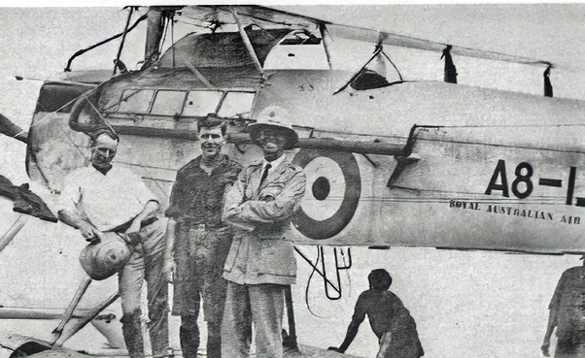
Flight Lieutenant Ivor McIntyre, Flight Sergeant Les Trist and Group Captain Richard Williams with their RAAF DH.50A seaplane at Buna, Papua during their historic 6,000 kilometre Pacific Islands survey flight.
The major aviation event in Australia in 1926 was undoubtedly the flight made by the Chief of the RAAF Air Staff, Group Captain Richard Williams and his crew along the east coast of Australia and through Papua New Guinea, New Britain, the Solomon Islands to Tulagi and return. It was the first RAAF overseas flight, and the first flight by an Australian-based aircraft to areas beyond Australian territories.
The hundredth anniversary of the flight is a good opportunity for collecting new information, particularly at a local level: please contact me at tomlockley@gmail.com if you can help. It may be possible that some commemorative activities will be held.
The flight left Point Cook on 25 September 1926 and returned on 7 December. Despite its importance, it is not well-known to the Australian public, hence this post. The booklet and file , First to the Solomons, can be downloaded here.
In 1926, the RAAF needed to make its presence felt. RAAF personnel Stanley Goble and Ivor McIntyre had made headlines in 1924 by making the first flight around Australia, and Richard Williams, Chief of the Air Staff, was keen to build on this by making a survey flight of the British possessions in the Pacific, flying some 27,300 kilometres (17,000 miles) to Samoa and return. The object of the flight ‘was to gain knowledge of the geography and flying conditions of the islands in the Pacific adjacent to Australia for air defence purposes.’ The planned route for this pioneering journey was through the islands of Papua New Guinea, Solomon, New Hebrides, New Caledonia and Fiji, to Samoa and return. However, in the event, the flight finished at Tulagi, in the Solomon Islands, as per the map on page 9.
The subsequent history of Australian aviation in New Guinea, both civil and military, testifies to the importance of this flight:
- New Guinea was an early adopter of air transport. The opening up of New Guinean gold mining efforts in the late 1920s were very much handicapped by difficulties of transport: the entire country is mountainous, there were no roads and aircraft were far more efficient. Amazing feats were performed in the years before World War II.
- During World War II New Guinea was the theatre for significant battles: air transport in particular was a major factor in the vital victories won in this area.
- Modern New Guinea could not survive without the hundreds of aircraft that enable efficient transport throughout this mountainous jungle country.
And finally the recent conclusion of the Papua New Guinea – Australia Mutual Defence Treaty once again underlines the importance of mutual cooperation, of which aviation is a vital part.
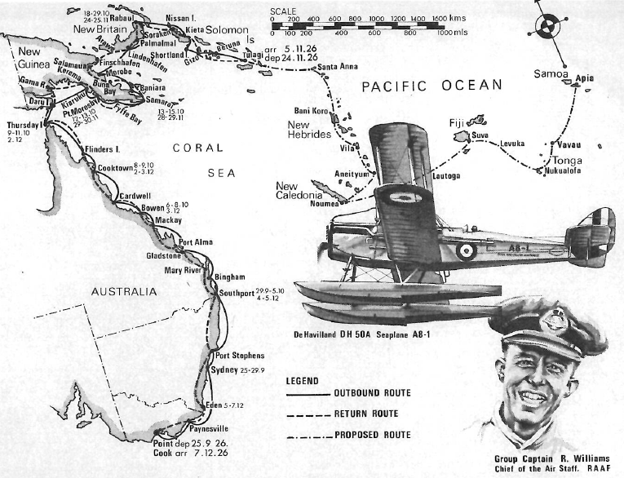
Map from AIRCRAFT, March 1977

Preparations
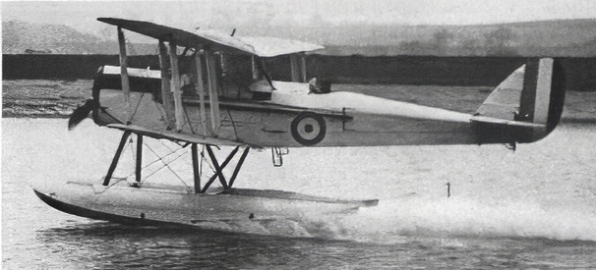
Most of the route was over water, and there were very few landing fields, so a seaplane was desirable . The best choice was the DH.50A, which had been ordered with an interchangeable wheel and float undercarriage. It was a modern-looking aircraft with an enclosed cabin for up to four passengers. Importantly, the Siddeley Puma engine of the DH.50A, with its low compression, permitted the use of ordinary motor spirit which was the only kind of fuel available for most of the journey. The logistics for the Goble / McIntyre flight around Australia were very challenging as supplies of aviation fuel and oil had to be relocated at 37 sites around the coastline. Goble had only succeeded in getting ministerial approval for his flight because he was acting Chief of the Air Staff in 1924 when Williams was overseas. In 1925 the situation was reversed: Goble was overseas.
The DH.50A had been tested as a seaplane at Shorts works at Rochester, UK ( picture above) in April 1926. The aircraft was formally accepted for the RAAF on May 4, 1926, by Stanley Goble in his role of Commonwealth Liaison Officer at the Air Ministry, and it was then shipped to Australia. It arrived at RAAF Point Cook in August 1926 and was given the serial number A8-1 and it became the first aircraft to be labelled ‘Royal Australian Air Force’ – in small letters under the serial number.
After much effort, ministerial approval was gained for the flight, despite concerns over safety issues.
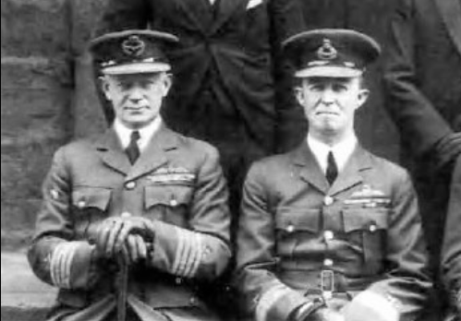
The aircraft was quickly prepared for the flight. The twin floats were fitted and Williams personally tested the seaplane on the 11 September. There were very few aircraft radio stations along the route, so it was decided not to carry a wireless operator and 54kg (120 1b) of wireless equipment was removed. Because they had only a three-person crew, they were able to carry a considerable number of tools and spare parts, which proved to be of great benefit.
A rare picture of Goble (left) and Williams together, 1930.

The crew
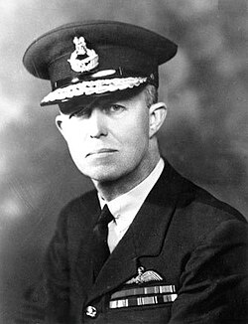
Air Marshal Sir Richard Williams, KBE, CB, DSO (1890-1980) was a self-made man. His father was a miner. Aged 19, he enlisted in the South Australian Infantry Regiment and was commissioned in 1911. In November 1914 he graduated from the first -flying course held at the Central Flying School, Point Cook, Victoria.
Late in 1915 he joined the first Australian aviation unit sent overseas for service with the Royal Flying Corps. The squadron began operations as a separate entity in December1916, supporting the Egypian Expeditionary Force in the advance towards Palestine. Richard Williams was awarded the Distinguished Service Order for acts of conspicuous gallantry and assumed leadership roles. He finished the war as temporary lieutenant-colonel, second in command of 4th (Army) Wing, Palestine Brigade, RFC.
Despite his comparatively young age (and his working-class background), his administrative skills were recognised, and he took a prominent part in setting up the Royal Australian Air Force and in 1922 was became chief of the Air Staff. He continually worked towards developing a strong and independent air force. In late 1926 he led the flight to the islands north of Australia which is the subject of this booklet.
Williams had a distinguished career in the Australian air force and held important overseas positions. During World War II however, Australian officers were denied the opportunity of commanding the Australian air force. The situation is very complex and has been the subject of many PhD dissertations, impossible to summarise in this short document. After the war Williams became Director-General of civil aviation and his work over the next ten years certainly ‘created the network of airfields, communications and related support services required by the industry, while maintaining an enviable safety record’. But that is another story!
Lieutenant Ivor Ewing McIntyre, CBE, AFC (1899-1928) was born in Scotland. During World War I he served with the Royal Naval Air Service and was a very skilled aviator, specialising in seaplanes. He came to Australia in 1923 to take up a commission in the RAAF, and took up duty with 5 Squadron RAAF, flying Fairey IIID seaplanes, based at Point Cook. He immediately took part in major flights, notably the first flight around Australia, as pilot for Wing Commander Stanley Goble. His pre-eminence as seaplane pilot is shown by the fact that he was also selected for the Williams flight. Ivor remained in the air force until 1927 and then became chief instructor for the South Australian section of the Australian Aero Club. Sadly, he was killed in the crash of a Cirrus Moth on 11 March 1928.
Flight Sergeant Leslie Joseph Trist (1898-1931) joined the army in 1918. He was a talented engineer and secured a position in military aviation. In 1926 he was a Sergeant in the RAAF and is listed as ‘mechanic’ in the records of the Pacific flight. He left the RAAF in 1927 and joined Airgold, a pioneering air transport firm in New Guinea, as pilot. Guinea Airways took over Airgold, and Les joined them as pilot. He was an important pioneer of the wonderfully successful air transport services in New Guinea and was killed in the crash of a Junkers W34 on 22 May 1931.
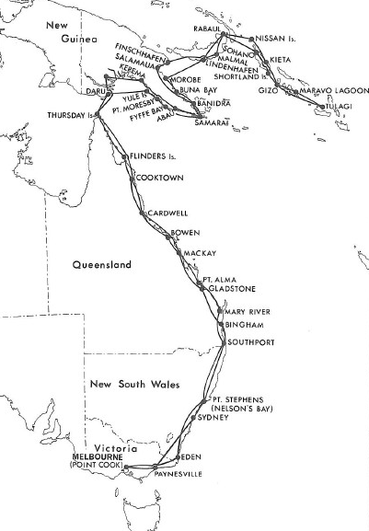
Route of the completed flight

Diary of the expedition
Friday, 24 September: planned date of departure, but a rough sea off Point Cook prevented the heavily laden seaplane from lifting off.
Saturday, 25 September: Point Cook to Paynesville (fuel stop), 0550-0850, duration 3.00: When the seaplane alighted at Paynesville, on the Gippsland Lakes in Victoria, to take on fuel, it was found that a small external leak had developed in the engine's water jacket. Paynesville to Sydney, 1019-1540, duration 5.21: the aircraft landed in Rose Bay amidst the normal Saturday afternoon's conglomeration of pleasure craft on Sydney Harbor.
The seaplane was beached and, after an inspection of the leaking water jacket, it was decided to change the engine. The replacement Puma – one of those supplied with the 1920 Imperial Gift equipment – was obtained from Wing Commander L J Wackett's RAAF Experimental Section at Randwick. The engine change took three days, and the aircraft was ready to resume the flight on the 29th.
Wednesday 29 September: Sydney to Nelson Bay, (fuel)1035-1140, duration 1.05. Departure time was set for 1000 hours, but McIntyre had to taxi the seaplane around for 35 minutes to stir up the smooth water surface to enable the aircraft to lift off! (This indicates the narrow margins on which the aircraft operated! tl). Nelson Bay to Southport, Queensland, 1235-1800, duration 5.25. Strong headwinds. Shortly before 1700 hours, when the fliers were within 9.7 kilometres (six miles) of Southport, the engine suddenly failed and McIntyre had to make an emergency landing in the open sea. It was found that a split-pin had been dislodged from the pilot's throttle control, and the fault was quickly remedied. High seas, with waves of 3-3.6m (10-12ft) were running and it was impossible to take off again, so McIntyre set about taxiing some eight kilometres (five miles) to Southport. The failing light, and the spray from the breakers, prevented the crew from locating the entrance to Southport, and McIntyre had to skilfully taxi ashore through a high breaking surf. The firing of a Very light brought assistance from the local cinema which was screening a silent epic. A party of 50 men dragged the machine across the sand-dunes to a lagoon where McIntyre taxied to a secure position in front of the Grand Hotel. Over seven hours had elapsed since the forced landing, and the exhausted crew collapsed into their beds during the early hours of 30 September.
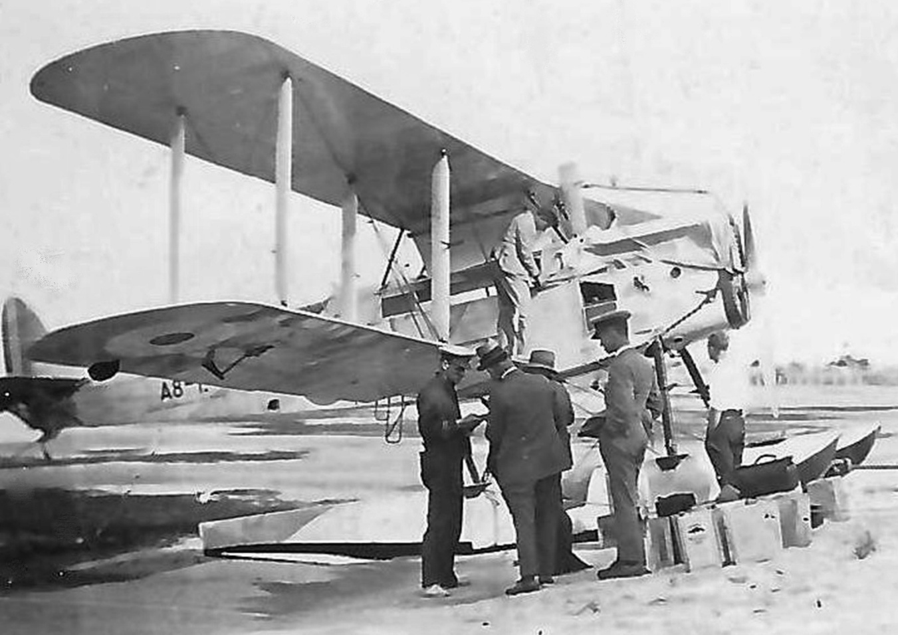
Thursday, 30 September: An inspection carried out later in the morning revealed that the propeller had been badly damaged and would have to be replaced. The only suitable propeller available was in the process of being built at the RAAF Experimental Section. Work on this propeller was hurriedly completed.
Meanwhile, the unfortunate incidents that had occurred to the seaplane since the fliers left Point Cook were being adversely reported in the newspapers. In fact, the Acting Minister for Defence was even called upon to cancel the flight. In the official report of the flight subsequently compiled by Williams he commented that ‘up to this time there had been a certain amount of press criticism regarding the flight. When the leak developed in the water jacket in Sydney it was said that this was to have been expected, as the Puma engine, which was being used, usually developed internal trouble in the water jacket. The one developed on the flight was external. When the machine failed to get off after the forced landing at Southport, it was assumed, in the press, that the reason was due to the limited performance of the machine. This was not so, for no seaplane could possibly have taken off from the sea running on that day.’
Preparing to leave Southport (RAAF photo)
Monday, 4 October: The propeller arrived at Southport. It was fitted and tested immediately, and the seaplane was readied for departure on the following morning.
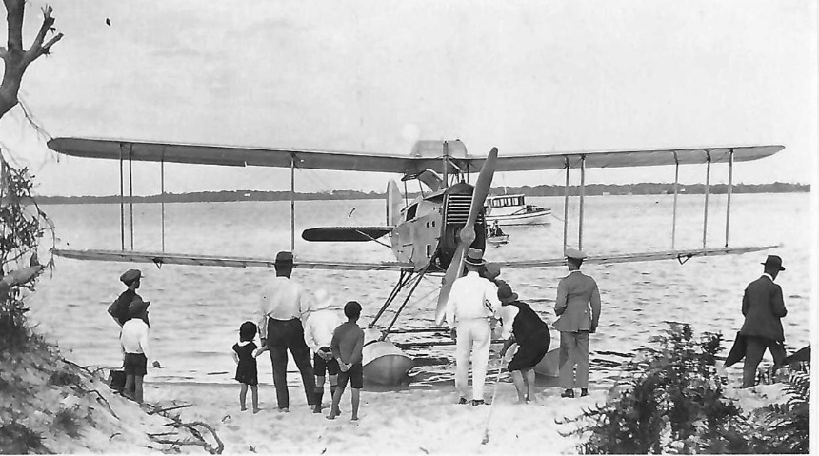
Tuesday, 5 October: Southport to Bingham (fuel, near mouth of Mary River, Hervey Bay) 0620-0920, duration 3.00. Bingham to Gladstone 1040-1320, duration 2.40.
This RAAF picture is labelled ‘Island Survey Flt. at Ashgrove, QLD’. But there is no mention in the sources of a stop at the Brisbane suburb of Ashgrove.
Wednesday, 6 October: Gladstone to Mackay, (fuel), 0650-1010, duration 2.40. Mackay to Bowen, 1105 to 1240, duration 1.25. The DH.50A was met and escorted into Bowen by one of the Seagull Ill amphibians of No 101 (Fleet Co-operation) Flight which was stationed in the area.
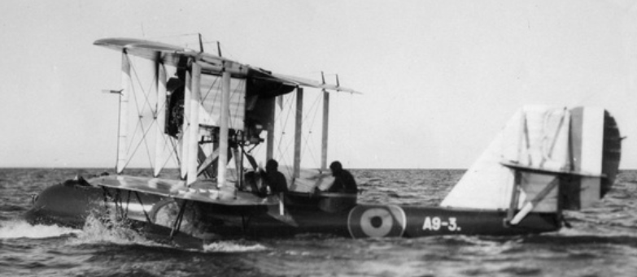
Thursday, 7 October: The aircraft remained at Bowen. Williams, as Chief of the Air Staff, inspected the flight, and flew out to the section of the Great Barrier Reef that was being photographed by the Seagull crews. A9-3 is shown.

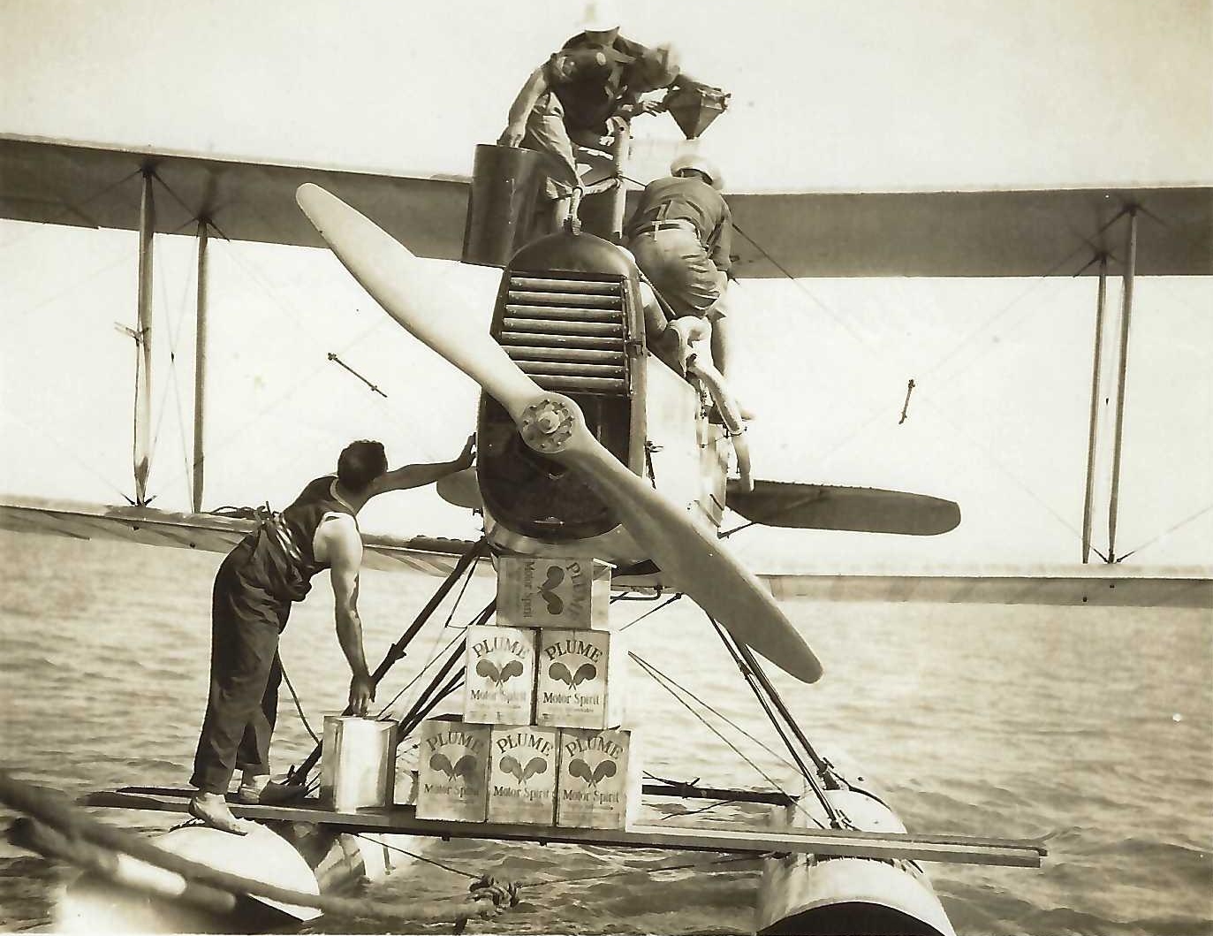
‘Filling up at Bowen’ – RAAF picture
There had not been much press coverage of the flight, but this increased considerably after they left Australia. This article is from the Sydney Sun of Monday 11 October.
Friday, 8 October: Bowen to Cardwell (fuel), 0935 to 1150, duration 2.15; Cardwell to Cooktown, 1237-1450, duration 2.13.
Williams: The next day via Cardwell we arrived at Cooktown. Here the whole town, a small handful of people, turned out to greet us and when proceeding to the hotel after refuelling, the mayor asked me if we would like to attend a dance that evening. Personally I did not feel a bit like a dance but it was obvious that the local people would like us to do that, so I said we would. Whilst we were having dinner at the hotel I heard a brass band playing in the distance and commented on such a small community being able to raise a brass bd. I was told it was playing at the hall where the dance was to be held.
When we arrived at the hall the band was playing outside, but before dancing commenced the whole band moved inside. The hall was built of corrugated iron without any lining and we certainly could hear the music, but we could not talk to our partners. Everyone was there including the children, some babies were in prams parked around the hall whilst here and there one was lying asleep on a form against the wall, quite capable of rolling off I thought but none did. It was quite a pleasant evening and seemed very quiet when the band had completed its program.
Saturday, 9 October: Cooktown to Flinders Island 1120-12.35, duration 1.15 (fuel); Flinders Island to Thursday Island 1328—1700, duration 3.32. The airmen stayed with the Garrison Artillery unit which was maintained there at that time.
At this point the DH.50A was about to become the first locally based aircraft to fly out of Australia. AIRCRAFT magazine later commented that ‘after an exchange of telegrams with Defence Headquarters on the advisability of pushing ahead or returning to Melbourne, the flight was resumed to Papua. … a section of the press was printing a lot of sheer nonsense about the difficulties encountered during the early stages of the flight. The then Minister for Defence was in England. His Acting Minister seems to have lent a credulous ear to those who wanted to have the flight stopped at Thursday Island and for a while there was some real danger of their representations being acted upon … actually, the flight didn't begin to grow interesting until after leaving Thursday Island, for most of the places called at in the Pacific had never previously been visited by aircraft.’
(Sunday, 10 October: delay awaiting approval to proceed)
Monday, 11 October: Thursday Island - Daru Island, Papua, 0817-1000, duration 3.32, 209 kilometres (130 miles) across the Torres Strait.
Williams: The water round these islands seems never to be clear of driftwood or other rubbish and we damaged our airscrew in trying to take off from Daru. Fortunately, it was repairable, but we had to stay there the night.
Tuesday, 12 October: Daru-Kairuka (Yule River), 1134-1500, duration 1.43, Kairuka-Port Moresby 1720-1810 duration 50 minutes. They flew along the Fly River Delta, and across the top of the Gulf of Papua where the aircraft flew into its first tropical storm. After landing at Kiaruku qq, Yule Island, for fuel, they reached Port Moresby at 1720 hours.
Willians: At Yule Island we met a number of young Australian nuns. It was dark by the time we got ashore at Port Moresby but we were met on the wharf by the Administrator, Staniforth Smith, who was acting for the Lieutenant-Governor, Sir Hubert Murray, who was on leave.
I stayed at Government House that night.
Wednesday, 13 October: Port Moresby-London Mission Station at Fyffe Bay (fuel) 0959-1312, duration 3.13; Fyffe Bay-Samarai Islandqq 1515-1610 duration 55 minutes.
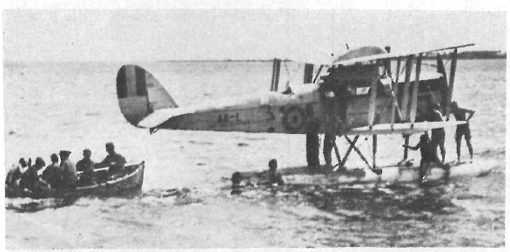
Williams: Our next destination was Samarai, but en route we landed at the London Mission Station in Fyfe Bay and accepted an invitation to lunch there. Up till now all the Papuan natives we had seen were what we call fuzzy-wuzzies, that is they wore a large quantity of curly hair.
Most of the missionaries we met seemed to live fairly comfortably. In the course of training the natives, all the labour they needed, whether inside the home or elsewhere, was available to them. Thursday, 14 October: Torrential rain held up the fliers for 24 hours at Samarai where they were guests of the Bishop of New Guinea.
Typical of the many PNG departure scenes, this picture shows the crew being taken out to A8-I and natives swimming around the floats note the repaired rudder with the red, white and blue stripes partly obliterated. (Isaacs’ original caption, RAAF Point Cook photo)
Friday, 15 October: Samara-Baniara 0933-1050, duration 1.17, Baniara-Morobe 1224-1520. Duration 2.56. While crossing Milne Bay the aircraft ran into a heavy tropical storm which caused the engine to lose power. McIntyre turned back to evade the downpour and, when the engine subsequently picked up, he flew around the storm area. Morobe was the first landing made in the Mandated Territory, and the party found a welcoming wire awaiting them from the Administrator at Rabaul.
Saturday, 16 October: ‘The next day was hot and muggy without a breath of wind,’ Group Captain Williams recounted in his report. ‘The surface of the sea was like glass, and a ground swell was coming in from the ocean. We had planned to fly to Lindenhafen, but under these conditions it was impossible to get off with the necessary load to make it in one flight.’
Sunday, 17 October: Morobe-Lindenhafen, 1150-1500. Duration 3.10. Conditions were much better and the seaplane was flown across the Huon Gulf, via Fami Islands, direct to Cape Bulli on the south coast of New Britain.
Monday, 18 October: Lindenhafen to Rabaul: 1337-1622, duration 2.45, 362 kilometres (225 miles).
Further telegrams were then exchanged with the Defence Department, culminating in authority being received to proceed beyond Rabaul – ‘Continuation of flight to Tulagi approved. Acting Minister desires impress no undue risks should be taken and feels flight should not proceed beyond Solomon Islands.’
At daylight on the 29th, A8-1 was flight tested with the two-bladed propeller that had been used since leaving Southport. The DH.50A was then temporarily fitted with a four-bladed propeller originally designed for the Wackett Widgeon I amphibian. The Widgeon's propeller had been positioned at Rabaul so that it could be tested in the warmer latitudes. ‘This propeller, however, caused considerable vibration and It was found to be out of true,’ reported Group Captain Williams. ‘It was not tested in the air.’
The normal propeller was refitted and the fliers departed from Rabaul at 1050 hours on the same morning.
After flying across New Ireland and clearing the east coast, the aircraft ran into rainstorms before arriving at Nissan Island. An inspection at Nissan revealed that an internal leak had developed in the water jacket of No 2 cylinder. Temporary adjustments were made and the flight continued on October 30 to Kieta.
Tuesday 19 October to Friday 29 October: an eleven day stop at Rabaul. : While awaiting approval to continue the flight an opportunity was taken to top-overhaul the engine. This work was completed on October 26, when a test flight was carried out. A Customs launch drifted into the tail of the machine and severely damaged the rudder. Wednesday, 27 October and Thursday, 28 October were occupied with repairs:
.Friday, 29 October: At daylight the aircraft was flight tested with the two-bladed propeller that had been used since leaving Southport. Then it was fitted with a four-bladed propeller originally designed for the Wackett Widgeon I amphibian. The Widgeon's propeller had been positioned at Rabaul so that it could be tested in the warmer latitudes. This propeller, however, caused considerable vibration and it was found to be out of balance, and the normal propeller was refitted.
Rabaul-Nissan Island, 1050-1300, duration 2.10. After flying across New Ireland and clearing the east coast, the aircraft ran into rainstorms before arriving at Nissan Island. An internal leak had developed in the water jacket of No 2 cylinder. Williams reported that water collected on the piston head when cold but that by soaking up this water with strips of cloth inserted through the plug hole the engine could be started up and kept running!
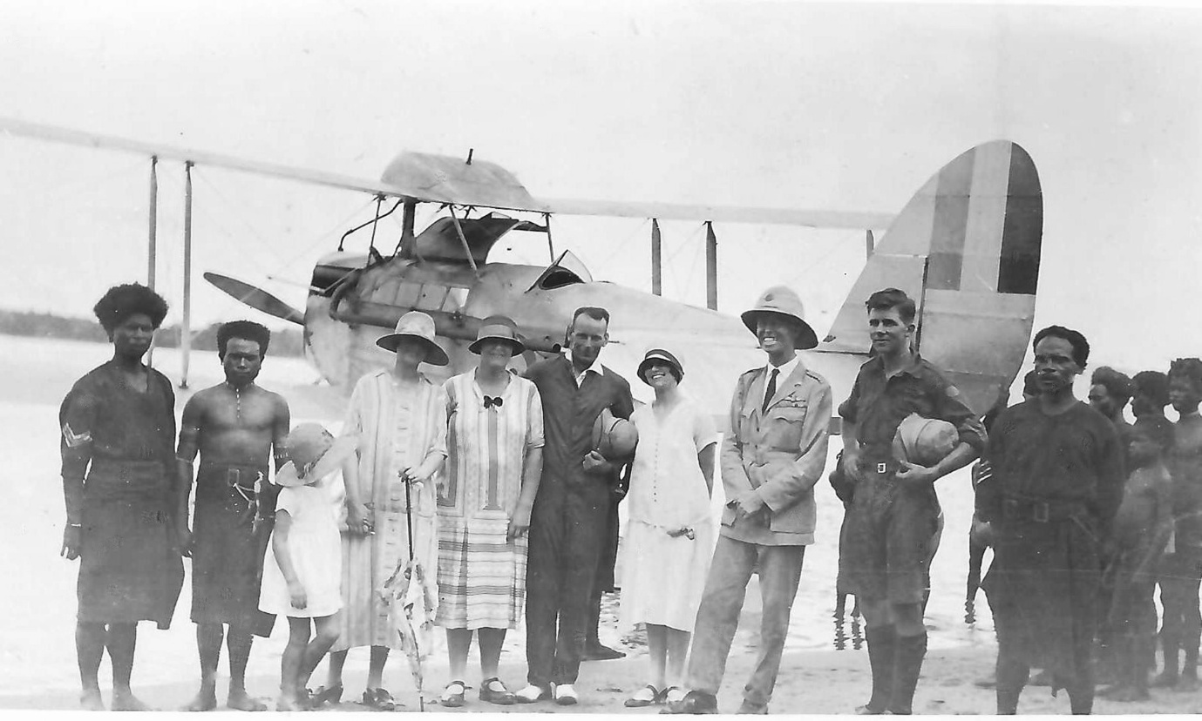
Here we found that we had an internal leak in the water jacket of one cylinder of our engine and that Unfortunately, this RAAF picture is unlabelled. Because of the repaired rudder, it must have been at Rabaul or later.
Saturday, 30 October: Nissan Island-Kieta, 137-1622, duration 2.45.
Sunday, 31 October: Kieta-Shortland Island. An attempt was made the following morning to fly to Gizo, but a landing had to be made at Shortland Island because of heavy rain and bad weather along the rest of the route. The weather, in fact, deteriorated so much that the aircraft was grounded for the following two days during which time it was found that the engine sump had cracked. Monday, 1 November and Tuesday, 2 November were occupied with repairs.
Wednesday, 3 November: Shortland Island-Gizo, 0850-1020, duration 1.30.
Thursday, 4 November: Gizo-Maravo Lagoon 0930-11.25, duration 1.15. A second take off for Maravo Lagoon had to be abandoned when the engine missed and vibrated badly under full power. The seaplane was beached, and it was found that No 6 cylinder had also developed a leak in the water jacket. Again, temporary adjustments were made—Nos 2 and 6 cylinders were freed of water through the plug holes, the engine was warmed up, and clean plugs were then inserted in the faulty cylinders just before take-off —and the fliers reached Maravo Lagoon and stayed overnight at Betuna.
Friday, 5 November: Maravo Lagoon-Tulagi, 11.25-1320, duration 1.55, 241 kilometres (150 miles). The seaplane was beached immediately at the Burns Philps island, Makambo. As Tulagi had now been made the terminal point of the survey, a new engine was requested from Sydney. The only Puma available was the engine that had developed the leaking water jacket on the flight from Point Cook to Sydney and had since been repaired at the Experimental Section.
Williams went down with malaria. The Resident Commissioner came with a doctor, and Williams was dismayed that he was Chinese, ‘The only Chinese I had ever met up to that time had been market gardeners or laundry men, and I am afraid this did not fill me with a great deal of confidence.
However, I found that the doctor had been trained at Edinburgh University and he proceeded to fill me with quinine until I felt I must burst. He obviously knew what he was doing for in a few days I was up and about and have not had a trace of the fever since’
Williams also commented that the people had not seen an aeroplane before there was consternation in the native villages as they passed over, men, women, children, pigs and dogs running in all directions. It was not long before the aircraft was being referred to by the natives as 'motor car belong Jesus Christ'. He ‘not very favourably impressed by the operations of European (principally Australian) storekeepers in the islands’. Most of the stores were in two sections, one for Europeans and the other for natives, and in the latter the prices charged were higher for the same article than in the European section. For example, a hair comb which was sixpence in the European section was one shilling – twice the price – in the native section. Williams was told that the natives did not understand anything but shillings, I found that very hard to believe. ‘Probably the occasion which shocked me most was at Tulagi when I saw a native outside a store with a camera which he had just purchased. It was a folding camera, and he was opening and closing it; obviously he did not understand it nor had he any knowledge of lenses or films, and of course he could get no photographs with it. It had cost several pounds’
‘Most of the natives employed by Europeans at that time were under contract for a period. They received a small weekly payment (perhaps in shillings), and were paid a lump sum, still not a large amount, on completion of their contract. The native I have mentioned could have had little more than enough to purchase his camera from such a final payment. I spoke to the storekeeper about the camera and told him what I thought of such a sale. His attitude was 'I'm here to sell things – it's not for me to refuse something a native or anybody else wishes to buy'. I am afraid this did not make me feel proud of being an Australian.
‘We called at several missions during this flight and sometimes I wondered just what the natives were being taught; at others I noted that they were being taught a great deal more of the Bible than I had been.
‘On one occasion at Tulagi I was being taken across the bay to Makambo Island in the Resident Commissioner's launch. The crew consisted of two natives, one attending to the operation of the engine and the other to the rudder. Natives who-had had some training at a mission station were referred to as 'mission boys' and whilst sitting in the stern of the boat I said to the man on the rudder, 'You mission boy?' 'Yes', he said, 'me mission boy'; then pointing to the man at the engine-I asked, 'Him mission boy too?' and was surprised to receive the answer 'No, him bloody heathen'.
Friday, 12 November: Engine shipped from Sydney
Sunday, 21 November: Engine reached Tulagi, engine installation
Tuesday, 23 November: Test flight in the afternoon
Wednesday, 24 November: Beginning of return flight: Tulagi-Gizo 0620-0840, duration 2.20; Gizo to Kieta 9.40-1130, duration 1.50; Kieta-Sarakanqq 1205-1310, duration 1.05; Sarakan to Rabaul 1205-1750 duration 2.40.Total for the day was 1,242 kilometres (772 miles), covered in 7 hours 55 minutes with landings at Gizo, Kieta, Soraken, and Rabaul where the seaplane alighted just before dark.
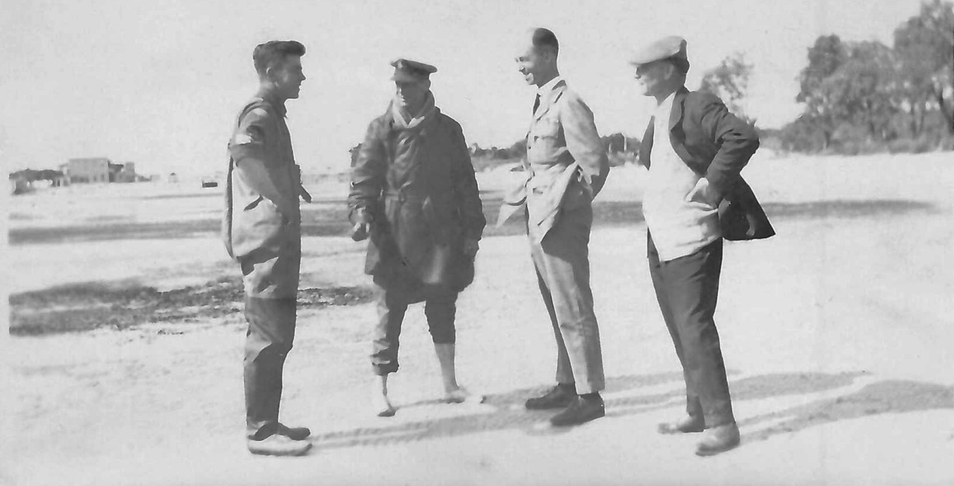
L/R, Trist, McIntyre, Williams, unknown person, unknown location!
Thursday, 25 November: Take-off at 1750, but forced to return to Rabaul because of ‘impenetrable storms’ after 30 minutes flying. Rabaul to Palmalmal (fuel)-1330-1530, duration 2.00: – ‘a plantation in Jacquinot Bay, managed by an Australian who had little communication with the outside world, and who inquired as to the winner of the Melbourne Cup and the result of the last Test match.’ Palmalmal-Lindenhafen 1600-1710, duration 1.10
Friday, 26 November: Lindenhafen-Arawe, 1253-1400, duration 1.07The following morning bad weather delayed the take off until 1253 hours, and the fliers arrived at Arawe at 1400 hours.
William’s comment: We were unable to get away from Lindenhafen on 26 November until after midday because of rain and got only as far as Arawe on the southwest corner of New Britain. Here we stayed at a coconut plantation, the manager of which was a bachelor and was away at the time, but who knew of our coming and had instructed his native boys to look after us. We were there for lunch and the boys produced a tray on to which a large tin of cold sausages and onions had been emptied. We helped ourselves to this but did not make much of an impression on it, so it -was on the table again for the evening meal and again for breakfast next morning. We did not seem to be very hungry that morning.
Saturday, 27 November: Arawe-Finschhafen 0858-1010, duration 1.13, Finschhafen-Salamoa 1110-1205, Salamoa-Buna Bay 1253-1445, duration 1.52., Continuous heavy rain then kept the aircraft grounded until 0900 hours the next morning. After leaving Arawe the crew flew to Finschhafen, Salamaua, and arrived at Buna Bay after travelling 470 kilometres (292 miles) in four hours flying time. The airmen were amazed to find that the next morning the wings were full of water, but no damage was done,
Sunday, 28 November: Buna Bay-Baniara1145-1325, duration 1.30, Baniara-Samarai 1355-1510, duration 1.15
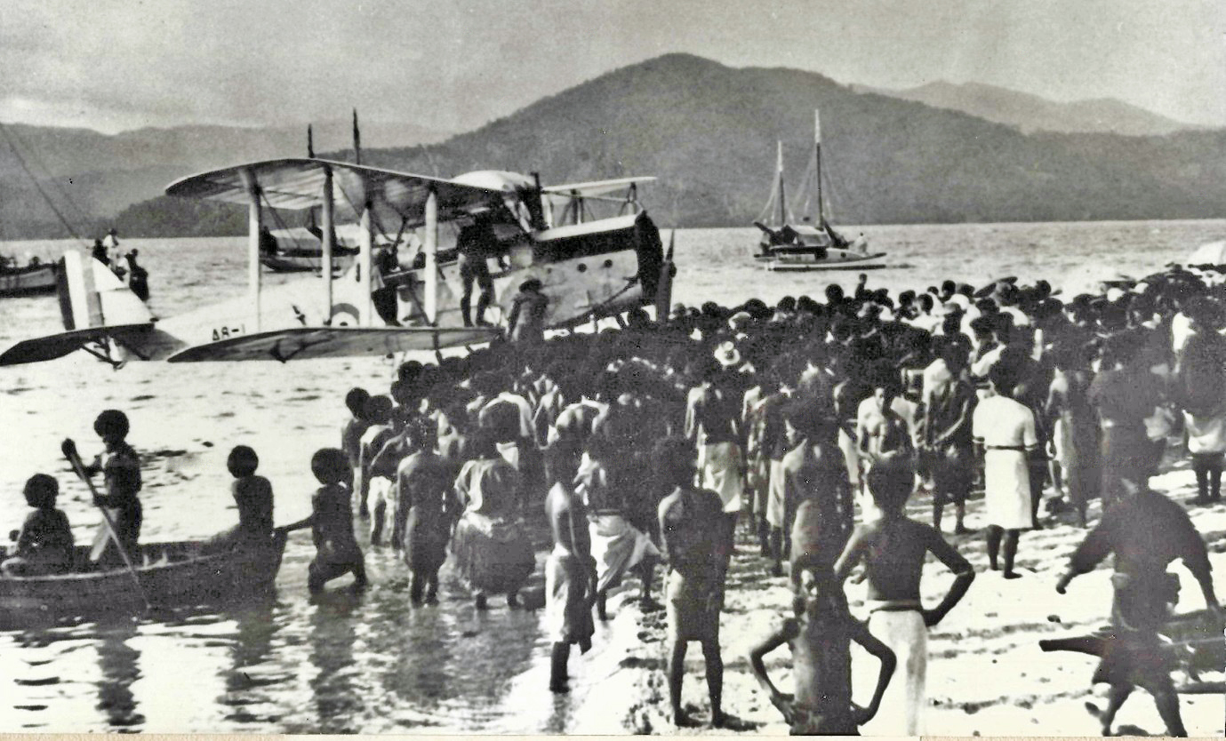
RAAF picture, Williams and McIntyre at Samarai
Monday, 29 November: Samarai-Abau (fuel)1155-1325, duration 130. Abau-Port Moresby 1357-1520, duration 1.23. Williams: We were now experiencing rainstorms every day and although it was possible to get round many of them we got no further than Port Moresby by way of Abau on 29 November …
Tuesday, 30 November: Port Moresby-Karema 0905-1145, duration 1.18, kilometres (142 miles) from Port Moresby.
Wednesday, 1 December: Karema-Bamu River 0812-1020, duration 2.08. The weather was still bad on December I when the fliers took off for Daru. About 90 minutes out from Kerema the aircraft encountered a storm of such magnitude that McIntyre was forced to turn back, and he alighted on the Gama River. The crew tied the seaplane to the river's bank and took shelter in a native hub with five of the local inhabitants. Efforts to speak to the natives in Pidgin English were unsuccessful and they waited until the rain had cleared. Bamu River-Daru 1300-1410, duration 1.10. The Resident Magistrate was most interested in the behaviour of the natives at Gamaqq River, because they had not seen a white man for two and a half years. On that occasion two village constables were appointed – but, when they arrived in their respective villages, they were promptly disposed of by the local inhabitants!
Thursday, 2 December: Daru-Thursday Island (fuel) 1008-1135, duration 1.27 Thursday Island-Flinders Island (fuel)1250-1645, duration 3.55, Flinders Island-Cooktown 1705-1850, duration 1.45, total distance 853 kilometres (530 miles)., 7 hours flying. ‘It was a good day’ (Williams).
Friday, 3 December: Cooktown-Cardwell 0710-0940, duration 2.30, Cardwell-Bowen 1000-1220, duration 2.20, Bowen-Mackay 1340-1505, duration 1.25, duration 1.45, and Mackay-Port Alma 1529-1830, duration 3.01, completing 1,143 kilometres (710 miles) in 9 hours 15 minutes flying time.
Saturday, 4 December: Port Alma-Gladstone 0906-0930, duration 24 minutes, Gladstone-Mary River 1027-1230, duration 2.03, Mary River-Southport 1331-1547, duration 2.16, total 595 kilometres (370 miles).
Sunday, 5 December: Southport-Port Stephens 0743-1105 (fuel), duration 3.22; Port Stephens-Eden 1242-1622, duration 3.40. The original intention was to fly to Sydney but, with such fine weather and favourable winds, Williams decided to bypass the harbor and proceed to Eden. Unbeknown to Williams reception had been arranged at Sydney and a formation of RAAF aircraft flew out to escort the aircraft into Rose Bay. When the seaplane failed to appear, fears for the safety of the crew began to grow until a sighting report of the seaplane was received from Jervis Bay.
Monday, 6 December: Bad weather kept the fliers at Eden on the 6th— the first and only day on which a flight was not made since leaving the Solomon Islands.
Tuesday, 7 December: Eden-Paynesville 0835-1133, duration 2.10, Paynesville-Point Cook 1045-1445, duration 2.10. Two Fairey III seaplanes had been launched to meet them but they failed to make contact. Three SE 5A fighters, and nine Avro 504 trainers then took off and accompanied them CAS's aircraft to Point Cook, where they alighted at 1512 hours, at the end of its epic journey. contact.

Summary:
The Pacific islands survey flight of 16,000 kilometres (10,000 miles) occurred between September 25 and December 7, 1926, and 126 hours 4 minutes were flown on 31 flying days. Of the 23 areas visited in Papua, the Mandated Territory of New Guinea, and the British Solomon Islands Protectorate, 20 of the districts had never seen an aircraft. The remaining three were visited by a Vought UO-I floatplane from an American battleship which called at the islands on the return voyage from Australia after the visit of the United States Fleet in 1925.
In retrospect, the flight would have been even more successful but for the misfortunes encountered with the seaplane's temperamental Puma engine. The fast return flight of 8,121 kilometres (5,046 miles) in 13 flying days demonstrated what could be achieved when the engine functioned normally and, of course, the original intention of surveying 27,300 kilometres (17,000 miles) to Samoa would have been accomplished but for the engine malfunctions.
In recognition of the fliers pioneering and surveying achievements, Group Captain Williams was awarded a CBE, Flight Lieutenant McIntyre a Bar to his AFC, and Flight Sergeant Trist an AFM, in the 1927 Birthday Honours. McIntyre also received the Oswald Watt Gold Plaque for 1926 (‘for achieving the most brilliant performance in the air during the year in the Commonwealth of Australia’) having previously been awarded the same medal in 1924 for the RAAF Fairey IllD seaplane flight around Australia. In his History of Australian Aviation (The Hawthorn Press, 1960), Stanley Brogden relates that ‘the flight was hailed at the time in England as another triumph for British aircraft.’
‘Of more importance than the honours and tributes. however, was the original report of the flight compiled in 1927 by Richard Williams. This comprehensive defence assessment was submitted to the Minister for Defence on May 31. The report formed the basis for strategic air planning in the Pacific islands adjacent to Australia until the advent of the 1939-45 War; when, of course, the PNG-New Ireland-Solomons theatre of war became an Achilles' heel in the Japanese plan to conquer the Pacific. There is no doubt that of all the flights made by Air Marshal Sir Richard Williams, RBE, CB, DSO, the most significant was his 1926 strategic survey.
Williams summary indicated that he certainly had not been converted to the merits of seaplanes. His view was definitely that they should only be used if there was no landing field available.
The Prime Minister at this time was Stanley Bruce, who was then in London, and he sent a congratulatory cable: ‘Congratulations on splendid achievement in your flight of ten thousand miles. You have demonstrated the wonderful possibilities of aviation, not only in linking Australia more closely with outlying portions of the Empire in Pacific, but also in defence of Australia and adjoining possessions.’

The 1927 round-Australia flight
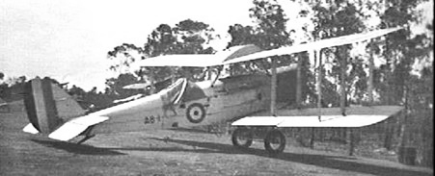
The DH50A was reconfigured as a landplane and was flown by Williams on a reconnaissance flight around Australia, with an additional flight from Adelaide to Tennant Creek, Two DH 9s accompanied the DH 50A for most of the way, and between July and September, the three de Havilland aircraft covered almost 13,000 miles.
DH50A at Fannie Bay, Darwin, 1927

Later history of the DH-50 in Australia
The DH50A used by Williams was written off in a crash in 1929. The type was popular in Australia and a total of 16 DH-50s were actually built in Australia under licence from de Havilland. QANTAS supplied a DH-50 to what became the Royal Flying Doctor Service in 1928 (below).
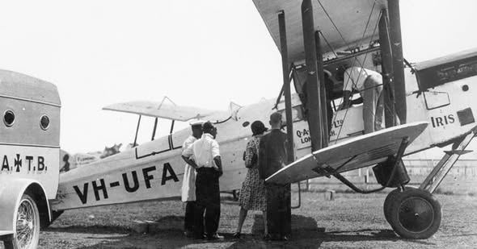

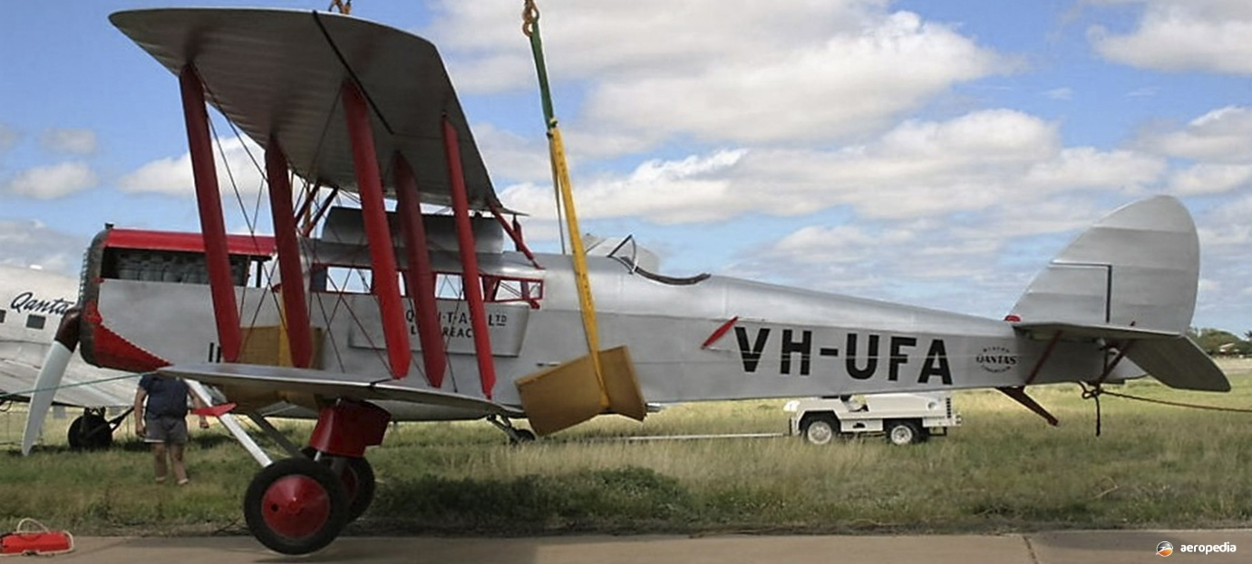
The original VH-UFA (above) and its replica at Qantas Founder’s Museum Longreach (David Eyre collection)

Philately of the Pacific Flight
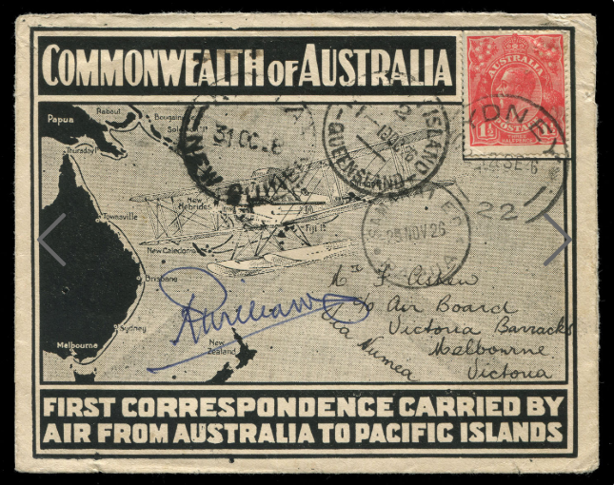
From Leski stamp sales catalogue, 2008:
‘A specially printed cover flown and signed by Group Captain Richard Williams on his survey flight which originated in Melbourne. This example addressed to the Air Board, Victoria Barracks, Melbourne with date stamps of ‘SYDNEY’, ‘THURSDAY ISLAND 10 OC 26’, ‘KIETA 31 OC 26’ and ‘SAMARAI 29 NOV 26’ . One was sold at Aeropex in Adelaide, December 2019 for $16,000.
Some covers were carried on a 50th anniversary flight in 1976 and others in a 75th anniversary flight in 2001.
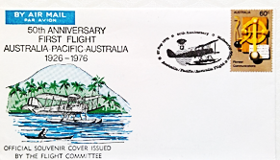

Independent State of Papua New Guinea (or Independen Stet bilong Papua Niugini in Tok Pisin) is the official name of the country known as Papua New Guinea, or more commonly as New Guinea. The southern part was originally Papua and the northern part, including New Britain and other islands, was German New Guinea until taken over in 1914 by Australia.

