102 Days
Vickers Vimy flight, Darwin to Adelaide, 1919-20
The flight of the Smith crew’s Vickers Vimy from Britain to Australia is one of the great aeronautical achievements of all time. Australians Ross and Keith Smith, Jim Bennett and Wally Shiers took off from Hounslow airfield on 12 November 1919 and 28½ days later landed in Darwin, after an amazing flight. They won the air race sponsored by the Australian government for this flight.
The fliers were keen to complete the journey, and though the aircraft needed attention, set off three days later to fly to Adelaide, the Smith’s home town. This is over 20% of the total journey. It was an epic flight in itself. It was at least as dangerous as the rest of the flight, and the airmen were faced with challenges of many kinds. It was also an event that had huge social effects, with positive consequences that remain with us today. But this part of the journey is comparatively neglected in the public record.
This booklet makes a preliminary summary of the flight and the opportunity is taken to briefly mention other activities: those leading up to the flight, and some later commemorations.
During 2019-20 major celebrations of the centenary are occurring. Some details are overleaf. The event of March2020 is designed to recognise the events described in this book. It will basically follow the same route, with a few detours, eg to Caboolture to enable a visit to Brisbane and to recognise the remarkable collection at TAVAS, which includes a replica of Ross Smith’s Bristol Fighter. To receive the latest information, send your email address to ahsasmithflight@gmail.com .
Tom Lockley
September 2018

Celebrations of the Smith Flight
In Adelaide, the History Trust of South Australia CEO Greg Mackie OAM leads the Epic Flight Committee. They have already succeeded in their principal aim, to ensure more appropriate display of the Smiths’ Vickers Vimy aircraft within the planned new terminal at Adelaide airport. Details: https://history.sa.gov.au/events/centenary-of-epic-flight/

On 10 December 2019 at 3 40pm Michael Smith will land his new Sea Bear adventure aircraft at Darwin airport, exactly 100 years after the arrival of Ross and Keith Smith, Wally Shiers and Jim Bennett, in Vickers Vimy aircraft G-EAOU. See his website http://www.southernsun.voyage/currentadventure

There are several other events at Darwin, details at https://ntmajorevents.com.au/great-air-race/

The Aviation Historical Society of Australia (NSW) is coordinating a flight by a group of aircraft from Darwin to Adelaide, to reach Adelaide for 23 March 2020, 100 years after the Vimy’s arrival.
Contact can be made by email ahsanswsmithflight@gmail.com or phone Tom Lockley, 0403 615 134. More details can be found on http://www.ahsansw.com/.

Second printing September 2019
Centenary Commemoration Committee
Aviation Historical Society of Australia (NSW) Inc
PO Box 301 Pyrmont NSW 2009
Thanks to Bob Livingstone and Dr Merrelyn Bates for corrections!

ISBN 978-1-64204-279-5


About this booklet
The airmen had hoped to fly from Darwin to Sydney in five days, leaving Darwin on 13 December 1919. They would then fly on to Adelaide. However they were delayed by mechanical failures and by en route celebrations, and they reached Sydney in 64 days. They reached Adelaide another 38 days later. This book provides a basic summary of the journey.
In a publication of this size, it is not possible to give comprehensive references for material used. The main book sources are Ross Smith’s 1921 book 14,000 Miles Through the Air, (online at the National Library of Australia), E Grenfell Price’s The Skies Remember (1969), QANTAS Rising, Hudson Fysh 1966, The Defeat of Distance, John Gunn, 1985, Australia’s Greatest Air Race, Nelson Eustis 1969 (and many of his philatelic publications), Flypast by Neville Parnell and Trevor Boughton, 1988, The Greatest Flight, Peter McMillan, 1994, the historical writings of John Scott and the late Keith White of AHSA NSW, my own previous booklets (list inside back cover), the online series of South Australian Aviation Museum Significant Aviator Profiles, the website http://www.adf-gallery.com.au/ and also Flight magazine and Aeroplane magazine. But probably the major source has been the magnificent Trove NLA website. This information is not always accurate, as is noted in the text. Trove and other material used is online at http://www.ahsansw.com/ and if the information you need is not readily found please email me at tomlockley@gmail.com
For reasons of space and clarity some liberties are taken with quotes – ‘Sir Ross Macpherson Smith, K.B.E.’ is simply referred to as ‘Ross’. Present spellings are preferred, eg Anthony Lagoon, not Anthony’s Lagoon.
I am very happy to receive corrections and comments, and I would also be delighted to include additional information on the website.
Tom Lockley, November 2018

Contents

Preliminary: 10-13 December 1
Day 1: 13 December 1919: Port Darwin to Warlock Ponds: (350 km) 2
Day 2: 14 December: Warlock Ponds to Cobb's Creek: (480 km) 3
Day 5: 17 December: Cobb's Creek to Anthony Lagoon: (32 km) 5
Day 6: 18 December: Anthony Lagoon to Brunette Downs: (80 km) 5
Day 7: 19 December: Brunette Downs to Avon Downs: (290 km) 6
Day 8: 20 December: Avon Downs to Cloncurry: (370 km) 7
Day 10: 22 December: Cloncurry to Longreach: (480 km) 8
Day 11: 23 December: Longreach to Charleville: (530 km) 9
Repairs and delays 11
Day 62: 12 February 1920: Charleville to Bourke: (420 km) 12
Day 63: 13 February: Bourke to Narromine: (370 km) 14
Day 64: 14 February: Narromine to Sydney: (320 km) 15
Day 68: 19 February: Mascot to Richmond 18
Day 73: 23 February: Richmond to Cootamundra: (385 km) 18
Day 74: 24 February: Cootamundra to Henty: (130 km) 19
Day 75: 25 February: Henty to Melbourne: (350 km) 20
Melbourne, 26 February to 21 March 21
Day 102: 23 March: Melbourne to Adelaide: (690 km) 22
The later stories 25
Appendix1: the ‘Aerial Services’ expedition, 1919 27
Appendix 2: Fysh, McGinness; the air race and QANTAS 28
Appendix 3: Wrigley and Murphy: first flight across Australia 29
Appendix 4: Richmond (Ham Common) 31
Appendix 5: The 1969 air race 32
Appendix 6: Lang Kidby and the 1994 re-enactment 32
Appendix 7: Philately 35

Preliminary: 10-13 December
The Vimy landed at Darwin at 3pm on 10 December 1919. According to a Sydney Morning Herald article of 29 December, the population of Darwin, ‘excluding Aborigines’, but ‘even including the Asiatics among the whites’ was about 2000; there were only about another 2000 such inhabitants in the entire Northern Territory – less than one non-Aboriginal per hundred square miles.
So a comparatively huge crowd of hundreds of people was present at the ground to welcome the aviators and the next few days were a round of activities. Ross expressed surprise and delight at the Darwin people’s hospitality.
After being enthusiastically received, the airmen were the guests of Mr Staniford Smith at Government House, where they were confronted with hundreds of congratulatory telegrams and cables. They had not realised that their flight had attracted huge attention.
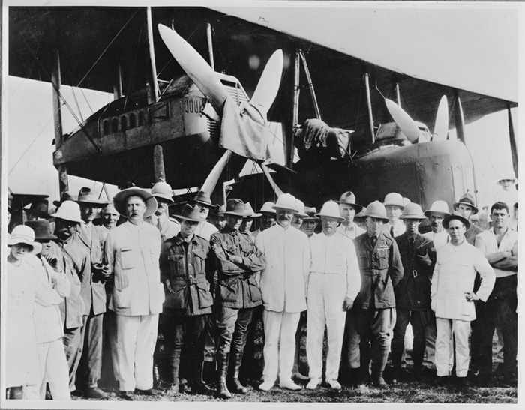Inspecting the Vimy at Darwin. NLA photograph.
On 12 December Captain Wrigley and Lieutenant Murphy arrived in Darwin, having completed the first transcontinental flight in their obsolete BE2e aircraft (see page 29).
The Vimy’s engines had done 135 hours and were 35 hours overdue for a ‘top overhaul’. The port propeller, which had hit a ‘kite eagle’ at Calcutta, was showing signs of splitting, but the Smiths decided to fly on. The ‘wet season’ was approaching and they feared that the Vimy, left in the open, might be damaged in storms. On Saturday, 13 December, they headed south, hoping to be in Sydney in five days.

Day 1: 13 December 1919: Port Darwin to Warlock Ponds: (350 km)
The next three sections of this book are based heavily on Ross Smith’s record of the journey, 14,000 Miles Through the Air. Communications were very poor until the airmen reached Cloncurry, and there are many unanswered questions about this section of the flight. It is hoped that the centenary commemoration will shed light on this exciting period.
The Vimy took off from the Fannie Bay airfield at 10.20 am and followed the overland telegraph line which ran from Darwin to Adelaide towards their first scheduled stop, Anthony Lagoon.
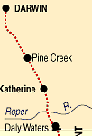
It was very hot and uncomfortable, and after about four hours of very bumpy flying, valve trouble developed in the starboard engine and Ross landed the aircraft at Warlock Springs, near Mataranka (14.9234° S, 133.0664° E), not far from where the Overland Telegraph crosses the Roper River on the map (left).
The ground was rough, but they landed safely and Shiers soon had the engine fixed.
Because of the poor flying conditions, they decided to stay overnight. However, after sundown they were attacked by mosquitoes and Ross wrote that he had never known insects so venomous. Sleep was impossible, and they tried huddling in blankets (too hot!) and lighting fires, but nothing deterred the insects.
About midnight, Ross remembered a bottle of ‘good Irish whisky’ that they had carried from England and opened it. He wet his face with the whisky, hoping to keep the insects away, but they ignored it, and Ross noted wryly that the others learnt from his error and put the whisky to far better use!
They had no sleep until daylight and their start the next day was delayed until 10 am. Ross had noted that this was the first mechanical failure they had had during the entire journey so far, but the next day was to bring more problems.

Day 2: 14 December: Warlock Ponds to Cobb's Creek: (480 km)
This was even hotter than the previous day, and the flight was even more bumpy. Ross had to work hard to keep the machine under control. They turned southeast after leaving the telegraph line at Newcastle Waters.
14.000 Miles has an interesting insight on how the airmen found their way around. ‘There was nothing on our map to guide us, but the stockmen in Port Darwin told us that if we flew southeast from Newcastle Waters for about 100 miles we would see two large patches of scrub which almost met each other in the form of a V. Then if we went down low, we would see the tracks of a mob of cattle that they had driven over there a few months previously. A few miles further on we would come onto a rough bush road that led on toward Cloncurry’. This ‘rather novel’ form of navigation worked quite well.
However, suddenly a blade of the port propeller split throughout its whole length. Ross shut off both engines and landed near a tent pitched near a track about a mile ahead. (Estimated position is about 18.000°S, 135.121° E).
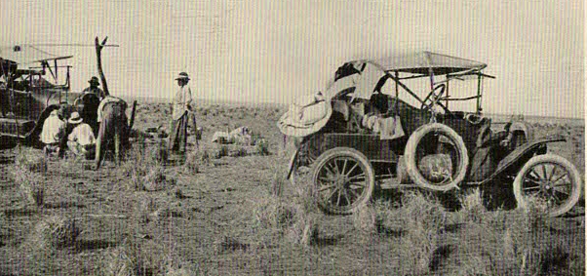
They feared they would have to walk 30 km to the nearest habitation, Anthony Lagoon, where there was a police station and a petrol depot. But to their delight two motor cars approached, carrying Sydney Peacock, who had been sinking an artesian bore, and the local policeman Sergeant Stretton.
Bearing in mind the sparse settlement of the Territory, this was incredibly good luck. The fliers had little food and no water in the Vimy.
The motorists left the necessary supplies and obtained more from Anthony Lagoon. Sydney Peacock left a sheet of galvanized iron, with which Jim Bennett planned to repair the propeller. For three days the crew worked on this task, with limited tools. Bennett carved pieces of a packing case to repair the propeller, glued them in, and reinforced the joints with screws taken from the aircraft floorboards. He bound the propeller with strips of iron, covered it with fabric and painted it. They did the same to the opposite propeller blade to maintain balance.
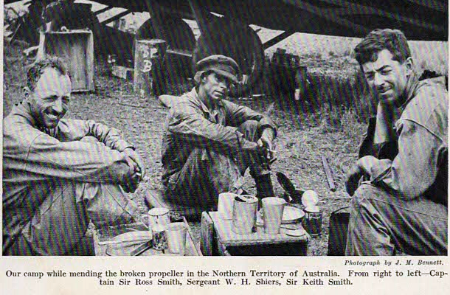
Conditions were appalling. A temperature of 125°F, 51°C was so fierce that it damaged the crew’s ‘Triplex’ goggles and the aircraft windscreens. Water, dragged up in a bucket 150 feet from the bore water level, was brackish and dirty, causing stomach upsets, but on the second night a thunderstorm enabled them to collect some fresh water. Despite everything, spirits were high; they were happy to be in Australia and appreciated having ‘no one to worry us and ask the same old innumerable questions about the speed of the machine, its weight, where we sat and so forth; it was the first real rest that we had had’. They were eating tinned meat and biscuits, but Ross records that Keith caused amusement with the old joke ‘if we had some ham, we would have some ham and eggs, if we had some eggs’.

Day 5: 17 December: Cobb's Creek to Anthony Lagoon: (32 km)
To their delight the propeller worked well. Take off was at 6 pm and flight took about 15 minutes. (The Google Earth location for ‘Anthony Lagoon’ is 17.983° S 135.533° E). The airmen stayed overnight, with Constables White and Kemp. Overnight there were major thunderstorms, with wild winds and heavy rain; on three occasions everybody had to hang on to the machine to prevent it being blown over.
Meanwhile, the ‘outside’ world was starting to worry: the delays described above caused concern and confusion. Anthony Lagoon was not on the telegraph line and news took a long time to reach the outside world. A search car was sent out from Charleville, about 700 km away! There were several conflicting stories before accurate news was received; a telegram was sent from Camooweal at 11 30 on 17 December. The Adelaide papers reported public jubilation as the news was spread through the city.
Meanwhile, it was announced that the Smith brothers would probably be awarded a knighthood, and that the aircraft would be acquired by the nation to be put on permanent display.
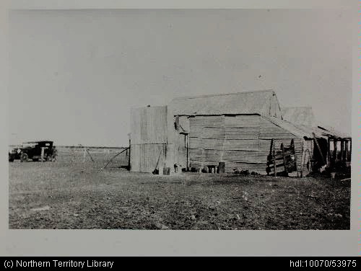
This picture of the Anthony Lagoon police station dates from 1929. No images of the 1919 visit have been found. Picture from NT Library collection.

Day 6: 18 December: Anthony Lagoon to Brunette Downs: (80 km)
(In his book, Ross devotes a scant three pages to the rest of his Australian journey. The book shows signs of hasty publication: there are errors of fact, typographic errors, and many blank pages at the end which indicate a lack of attention to detail in layout. But it remains an excellent primary source, particularly regarding the journey to Darwin. Thus, in this booklet, the ensuing narrative is based mainly on contemporary newspaper accounts. It is hoped that better information will emerge over the next few years!)
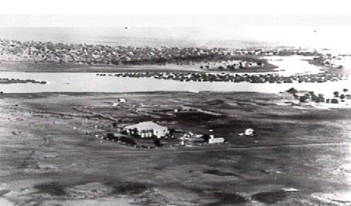
Again, there are not many details about this flight. Take off was at 10 05 am, and the flight took an hour. Brunette Downs (18.633 S, 135.950 E) was a more elaborate establishment, with ‘a good workshop’. The only contemporary picture that can be found is a poor-quality newspaper illustration; this picture taken in 1929 (from the NT library collection) is not much better. As a strong headwind was blowing, they decided to stay overnight, and were well looked after; the station manager was Mr Russell.

Day 7: 19 December: Brunette Downs to Avon Downs: (290 km)
As the airmen were preparing for takeoff a car arrived from Camooweal, loaded with petrol, driven by two brothers named Synott.
The aircraft took off at 11 05 am and the 180 km journey to Avon Downs (20.030° S, 137.487° E) took 2 hours 45 minutes. They passed over Alexandria Station and the nearby Rankine store. They were hospitably received by Mr and Mrs Lloyd and stayed overnight.
An excited Mrs Lloyd wrote details to her mother. They had put out a wind-indicating T signal on the ground, as instructed by McGinness. She described the excitement of the arrival; they tried to telegraph the news, but it was a half-day holiday and they could not get through for some time.
The airmen gave Mrs Lloyd a spark plug, and (daughter?) Moira a feather from the kite hawk which was responsible for damage to the propeller at Calcutta. They agreed to drop a bolt and message over Camooweal, which was later raffled for the benefit of the hospital.

Day 8: 20 December: Avon Downs to Cloncurry: (370 km)
Takeoff was at 7 45 am, and the 500 km journey to Cloncurry took three hours, averaging 100 mph, obviously with the help of favourable winds. The population gathered at the chosen airfield, being well informed by telegraph of the estimated time of arrival.
Mr Denman was the first to see the aircraft, the machine ‘seeming to be about the size of a magpie’. Gradually it grew larger, ‘passed over the town and sailed to the landing ground where it alighted gracefully’ amidst deafening cheers.
Lieutenant McGinness (see page 28) took a wing and guided the aircraft to a parking spot. Councillor Hensley welcomed the aviator, and presented Ross with an address (an elaborate manuscript message in a frame, which must still be retained somewhere). Ross Smith replied, telling of their recent adventures.
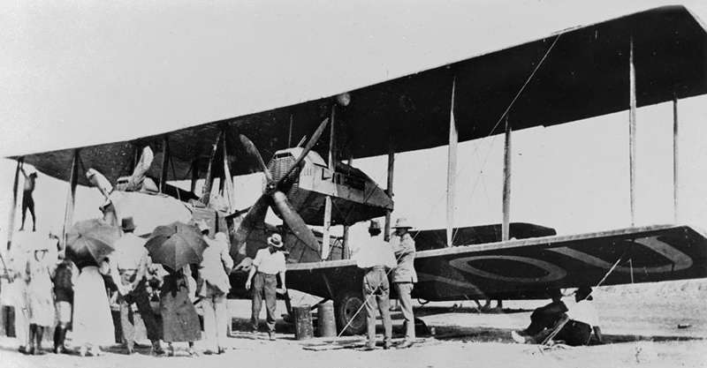
Cloncurry was the first major town reached by the airmen since leaving Darwin. The settlement was largely based on grazing and a large copper mine that had been established in 1867. It was quite a wealthy area and had been greatly boosted by the opening of the railway in 1907. From Cloncurry the world received definitive news of what had happened at Warlock Ponds and Cobb’s Creek, and here the Smiths learnt that they had been awarded knighthoods. Apparently one of the welcoming committee had knowledge of telegrams addressed to Sir Ross and Sir Keith Smith, and thus knew about the honour before the recipients did!

Day 10: 22 December: Cloncurry to Longreach: (480 km)
From the Barcaldine Western Advocate: A large proportion of the population came to see the early takeoff (6 50 am). The 300 mile, 480 km flight to Longreach took 4 hours 40 minutes.
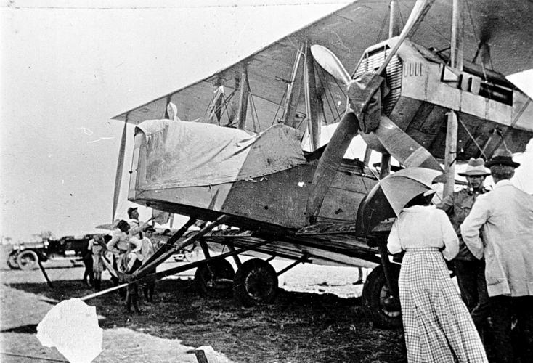
Flying low over the railway line, and over the heads of the crowd, which had been wisely kept back from the actual landing place by a rope barrier, the distinguished pilot made a perfect landing almost right on the calico T which had been previously laid down, under instructions received from the Defence Department.
There are photographs of the aircraft at ‘Portland Downs’ station, shown by Google Earth as being near Isisford, which is about 60 k south of Longreach.
The airmen were warmly welcomed and congratulated by the Chairman of the Shire of Longreach, Mr R H Edkins, and the citizens admired the Vimy and its world-famous crew. They noted that the seals on parts of the aircraft were still unbroken: ‘with the exception of a bandaged propeller, the plane appears to be in perfect order’.
Business people, councilors and representatives of various public bodies held a welcoming dinner at the Imperial Hotel, and in the evening a big public meeting was held in the Shire Hall. Ross spoke about the journey, giving full credit to mechanics Bennett and Shiers. The audience demanded a speech from all the other airmen. They were presented with ‘handsome cigarette cases, suitably inscribed: as mementos of their call at Longreach, and in responding Ross said that from the time they had landed at Darwin they had been hearing of Longreach hospitality, and had been urged, by Captain Wrigley and others, to be sure and make a landing there. They were pleased to find that all the good things said had been more than realised and thanked the people heartily for their reception.
The local newspaper reported: ‘On Tuesday, 23rd at 7.30 am, before a great crowd, some of whom had come over 70 miles to see the plane, the aviators made a splendid start for Barcaldine, Blackall, and Charleville, and as the machine soared higher, and higher in the sky, the rays of the morning sun caught it and transfigured it into a silvery vision, so beautiful that it will remain as a lasting memory with those who were privileged to see it’.

Day 11: 23 December: Longreach to Charleville: (530 km)
Takeoff was recorded as 7 05 am, and the flight duration was 3 hours 40 minutes. En route, the Vimy flew over Barcaldine. Mr Cotton, Vacuum oil representative at Barcaldine, had driven quickly to Longreach to greet the arriving aeroplane and arranged for messages to be dropped from the Vimy as it flew over Barcaldine. The local newspaper received a letter of Christmas good wishes and another card was signed by the entire crew. Individual messages were also carried.
Barcaldine decked itself out in decorative flags. Keeping posted by telegraph, the arrival of the plane was announced by two blasts from the whistle of the power house.
The population gathered to watch the aeroplane as it ‘sailed majestically over the town at a slow speed. People waved handkerchiefs and the youngsters hurrahed. Near the woolscour a packet tied to a piece of lead piping and decorated with long coloured silk streamers, had been dropped and thus was delivered the first aerial mail in Barcaldine. … ‘At the woolscour the plane took a turn and shot away south as if it were projected from ‘Big Bertha’, and in a few seconds was lost to view’.
Arrival at Longreach, at 11 30 am, was the usual sensation, with everyone attending. The aviators had decided to take an extra rest day here.
According to the Darling Downs Gazette, on Wednesday 24 December the aviators attended two functions.
‘At the School of Arts last night a public banquet was held. All the notables of the district were present’.
The Mayor, Alderman A J Carter, congratulated the Smiths on the recent announcement that they had been awarded knighthoods, and spoke of their great achievement. Ross Smith spoke for nearly an hour, retelling the story of his flight to a very enthusiastic audience. They intended to leave the following day, Christmas Day, for Sydney via Bourke. The Charleville Chamber of Commerce, the Town Council, the Murweh Shire Council, and the Soldiers League, also the local bankers, gave Sir Ross Smith and his party a special dinner at the Hotel Charleville. Ross suitably responded to the speeches of the dignitaries at this function.
On 25 December they took off early: the exact time was not recorded, but they were watched by a large crowd.
Soon after taking off at Charleville they had major engine failure, which is completely omitted from Ross Smith’s book.
Wally Shiers’ description is quoted in Grenfell Price’s book The Skies Remember. 'After spending two days at Charleville we decided to move on, so we went out early in the morning, … found the petrol was O.K., oil and everything, the maggies were all right, everything was going good … We took off. We were in the air about 3,000 feet, and Ross was just giving us the signal that he was heading for home. The next thing was a terrific bang, and a flash of fire came out past Benny and me, and we wondered, and thought we were gone. Next thing we saw Ross juggling with the throttles. He switched off the port engine and down she went into the deck, and there we landed just outside Charleville’.
Wally suggested that the makeshift propeller may have affected he engine balance. A connecting rod had completely broken, and fractured the sump, causing the flash of fire.

Repairs and delays
By 29 January, after many cables and telegrams, it had been decided to send the engine to Ipswich railway workshops, where it was planned to fabricate some new parts. Some parts were available in Australia, but the details are not clear. It transpired that one new cylinder, two new pistons, all conrods, six new valves and a new manifold were required. The hole in the sump was repaired. It was later revealed that the cost was £459. The Queensland government was happy to bear the cost, but asked that the broken propeller should be returned to Brisbane as a museum exhibit.
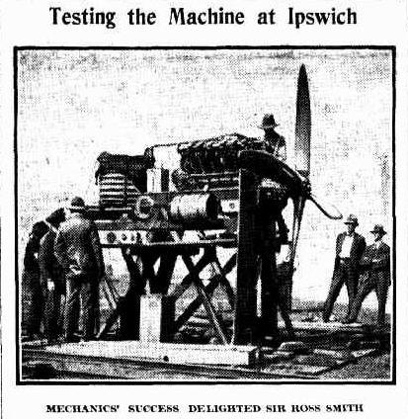
Exact movements of the crew are hard to work out from the newspaper reports. According to some reports, they spent some of the Christmas period duck shooting. Later it was reported that Ross Smith and Jim Bennett were taking the faulty engine to Ipswich while the others remained at Charleville and worked on the aircraft and the other engine. The Premier of Queensland, Mr Theodore, and the Railway Minister Mr Fihelly promised full co-operation, with workmen continuing to work over the holiday period, and Mr Fihelly was en route to Ipswich to meet Ross Smith when he arrived.
Regardless of the details, the Smith brothers and Jim Bennett were warmly welcomed to Brisbane on 6 January. Shiers remained with the aircraft and later Bennett rejoined him. The aviators were continually feted in Brisbane, and on 13 February Ross gave his opinion that an air service to Britain, taking 14 days, was imminent. Newspaper stories abounded: the progress of the engine repairs was a common subject. The Smiths made many public appearances in Brisbane, particularly visiting ex-service groups. There were many articles about Ross’ war record and his flying exploits, notably with the big Handley Page bomber in the Middle East and India. Under pressure for a visit to Sydney, Ross indicated that it would be a high priority once the aircraft was ready. A ‘docudrama’ film was prepared about the flight.
The repaired engine had a test run on 3 February. Barton Adams, of the firm of William Adams & Co, the Vickers agents for Australia, inspected the parts made at Ipswich and found them to be of excellent quality. The Smiths and Jim Bennett made a visit to Toowoomba on 4 February and were received with the usual enthusiasm: they made a tour of the town, including the newly created Anzac Avenue. Ross Smith shook the hand of every one of a guard of honour formed of Boy Scouts, and the Mayor gave an address of welcome.
On 11 February the repaired engine had been installed and tested, ready to resume the journey. The process was not entirely without problems: difficulties in flying the test flights were variously blamed on the propeller and on the ‘sticky’ black soil airstrip.

Day 62: 12 February 1920: Charleville to Bourke: (420 km)
The crew was joined by Captain Frank Hurley, famed Antarctic explorer, a good friend of the Smiths. He was an excellent photographer and took many of the best pictures taken on the trip, including some movie film.
The 14.000 Miles timetable is contradicted by the newspaper reports. First there was a trial flight. According to newspaper reports, The machine reached a height of over 4,000 feet in the trial. With Sir Ross were Sergeant Shiers, the mechanic, the Minister for Lands (Mr Coyne), Mr F J Arnold, representing the agents for Vickers Ltd, and [a Herald reporter]. They wore Antarctic-like headgear.
The passengers stated that they greatly enjoyed the experience except during the descent, when they felt a trifle bilious. It was a beautiful, sunny, breezy morning, with scarcely a cloud visible in an azure sky.
There was a large crowd including the Mayor, Alderman Carter, and Brigadier-General Irving (State Military Commandant), who was attended by Major Glover, DSO. Many people had travelled long distances to attend.
The take-off was near the Glengarry Hotel; the aircraft ran along the ground for about 500 yards, straight towards the hotel, on the north-western edge of the plain.
At about 11 10 am the airmen left for Bourke, making a circuit over the airfield, then heading south, following the Warrego River. The Brisbane dignitaries caught the 3 15 train, arriving home in the evening of the following day.
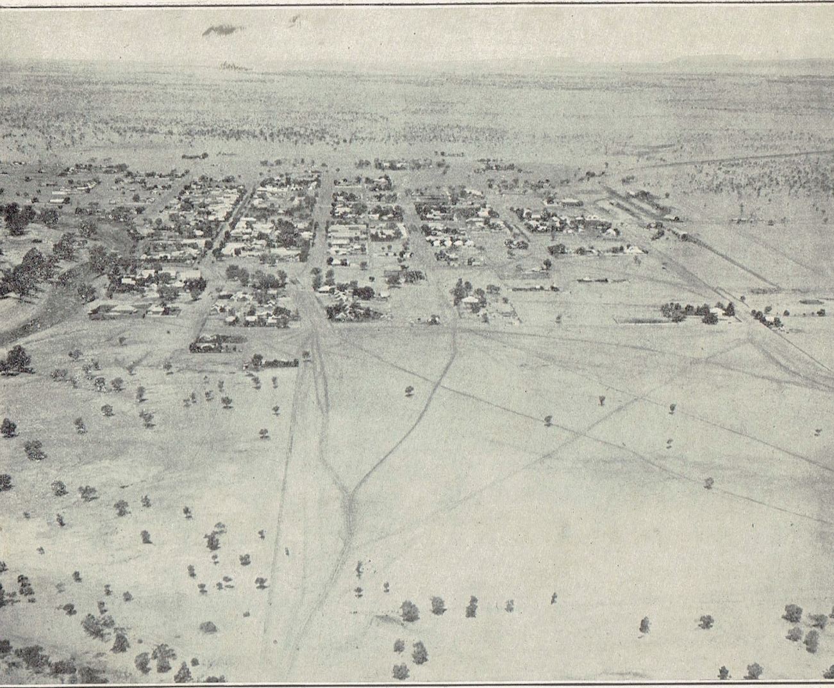
Frank Hurley’s picture of Bourke.
The Vimy reached Bourke, 260 miles (380 km) away, at 3 24. They were welcomed by a large crowd including people from Brewarrina and stations 100 miles out. The Mayor welcomed the aviators to New South Wales.
Ross stated that he and his crew had a rough trip from Charleville, and that the journey occupied four hours.

Day 63: 13 February: Bourke to Narromine: (370 km)
The facts from 14000 miles… are take-off from Bourke 9 am, arrival at Narromine at noon, distance 360 km. They followed the Warrego River.
After landing and partaking of refreshments, Sir Ross Smith was officially welcomed by Councillor Bishop, the Mayor, Councillor Scott, in the absence of Councillor Aldgay, the president of the ‘Dubbo, Kefford (sic) and Trangie Progress Association, and Mr Macdonald, of the Returned Soldiers League. Sir Ross Smith referred to the credit that was due to Sergeant Bennett and Sergeant Shiers, the mechanics. In the evening a banquet was held to welcome the airmen.
Bourke and Narromine did not have newspapers and their arrival at these places were covered only by short articles telegraphed to the major cities. Most stories were related to the anticipated arrival in Sydney.
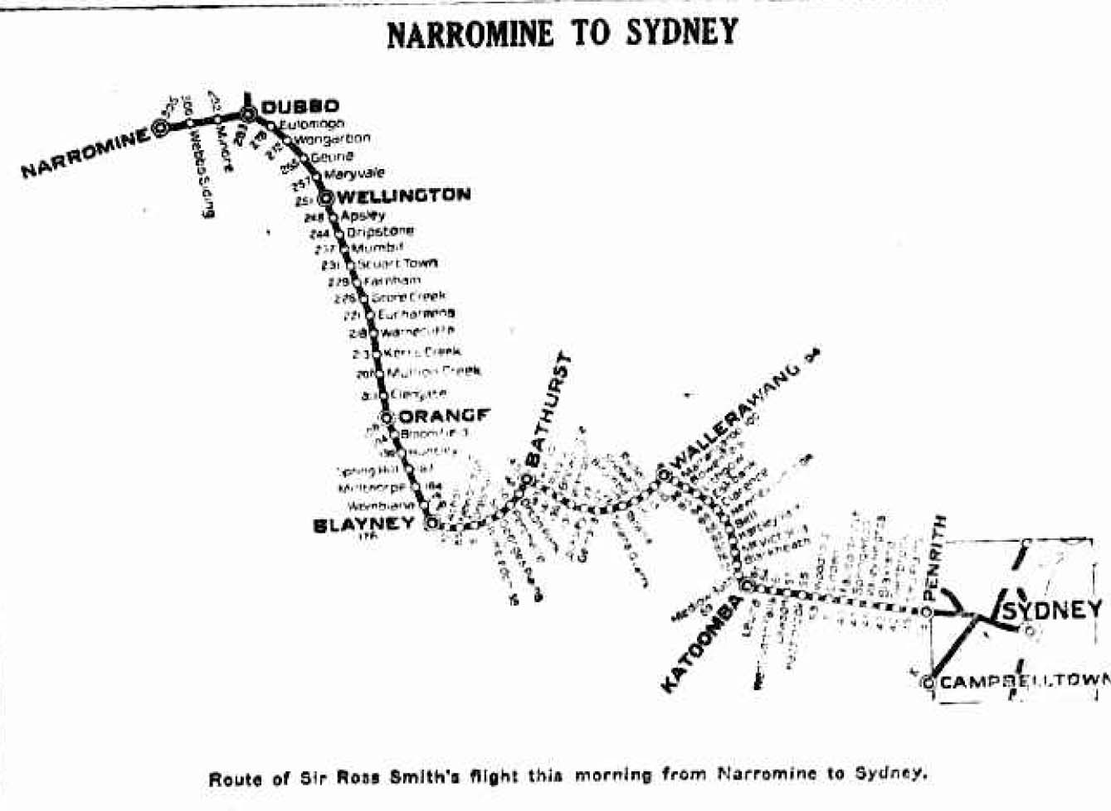
Narromine now has a wonderful air museum, a centerpiece being a flying replica of the Wright Flyer, the first aircraft to fly. Peter Kierath, of the Narromine museum, says that the Vimy was surrounded by a ring of empty beer bottles drunk during its overnight stay. The event would have been of major significance, but so far it is not well recorded. It is hoped that the coming commemorations will uncover many new facts about the journey and their visits to these towns.
The aircraft followed the railway line wherever convenient, not just for ease of navigation but also so as to fly over as many towns as possible.

Day 64: 14 February: Narromine to Sydney: (320 km)
14.000 Miles gives take-off time of 7 am, flight time 4 hours 15 minutes, distance as 230 miles, 370 km. The navigation this time simply consisted of following the railway line.
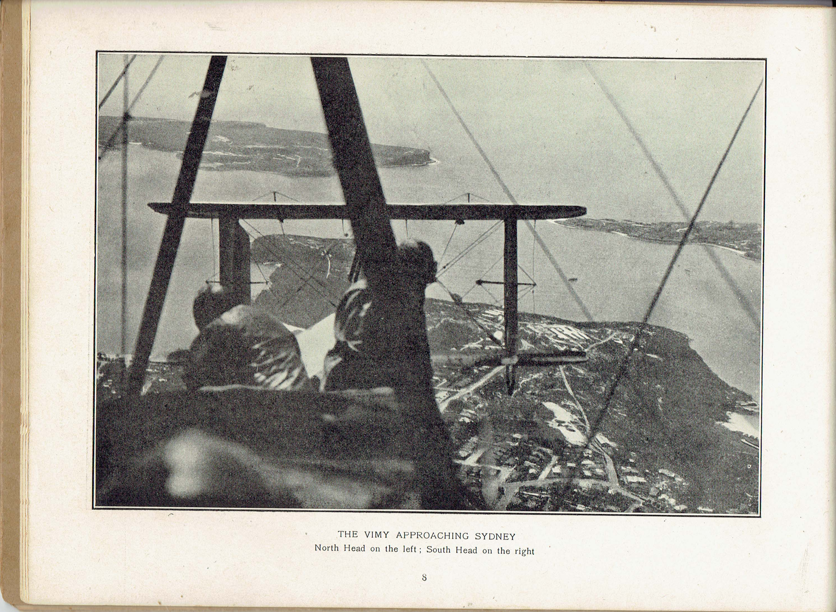
This arrival was very well publicised. Frank Hurley’s photos were widely circulated: they entered through Sydney Heads and took numerous photos of the city.
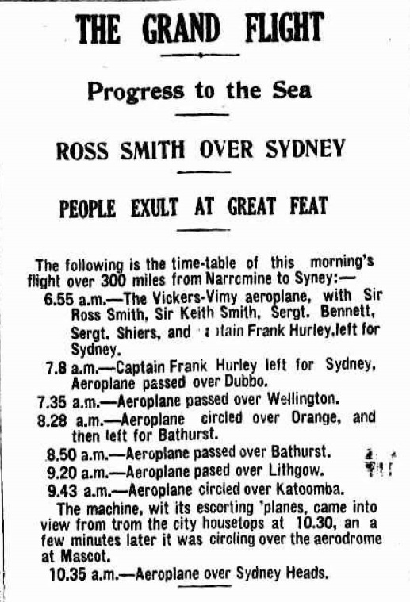
The Sun published a map of the flight and a timetable indicating the actual progress.
From the GPO Mr E J Young organised weather reports to be sent early in the morning to Narromine.
Three escort aircraft met the Vimy near Richmond, where NSW Government had established a School of Aviation – two Curtiss ‘Jenny’ aircraft from the school and an Avro 504 belonging to the Australian Aircraft and Engineering Company. Flight Lieutenant Le Grice led the formation and Flight Commander Leslie Holden DFC flew on the starboard side, with the Avro aeroplane on the port side, carrying a cinematographer. Ross Smith had negotiated that after taking pictures of the approach to Sydney, the escort aircraft would break away. The Vimy would fly out over the coast and enter Sydney through the heads and fly around the city, ‘thus affording opportunity for every citizen to witness the flight’.
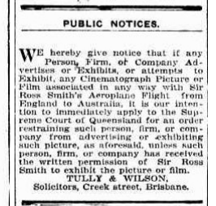
It appears that the Smiths asserted some control over matters of publicity. This advertisement appeared in the Brisbane Telegraph on February 13.
At Mascot, the Prime Minister, William Morris Hughes, was joined by aldermen of Mascot, members of the Australian Flying Corps, relatives, friends, and others. (The Smith brothers’ parents had arrived from Adelaide a few days before). Detailed plans were in hand: the general public were to be kept in a fenced area 300 yards away from the landing site until the landing was complete, then the aircraft would be brought nearer the crowd so that they could view it in an orderly fashion: Mr J S Cormack, of the Premier's Department, in charge of the event, promised that any trespassers in these matters would risk ‘serious consequences’. Perhaps the Vimy would be forced to land elsewhere if the crowd was unruly.
Motor traffic between Mascot and the city was to be controlled by traffic police under the supervision of Superintendent A Edward, and as the approach to the airfield was through a narrow, very rough lane, only a few approved vehicles could enter. Members of the forces, in uniform, would be allowed in. Special trams would be run.
Indeed, the whole city turned out to welcome the Vimy. ‘Crowds gathered at every vantage point. Seats on roofs and at windows sold up to a guinea each’. People boarded ferries early in the morning and stayed on them until the aircraft flew up the harbour. A great crowd assembled at the General Post Office, where progress reports were posted. 'Passed over Katoomba at 9.43' was a message which sent the crowds scurrying to vantage points. Cheers went up from the people massed on the roofs as the machine came into sight.
With three escorting machines, the aircraft was spotted from the city at 10 30 am and was overhead five minutes later.
Coming in from the heads, and flying very low, the machine flew around the harbour and the city. People cheered, ferry boats whistled, the bells rang, and ‘the air rang loud with rejoicing’.
As they flew over the city the aviators dropped coupons advertising tea made by blind ex-servicemen, then landed safely at Mascot aerodrome at 11 10. They were then transported to the Town Hall where Alderman Brookes praised their achievement, and Ross replied that they had the honour of making the flight and that many others could have done it if given the opportunity.
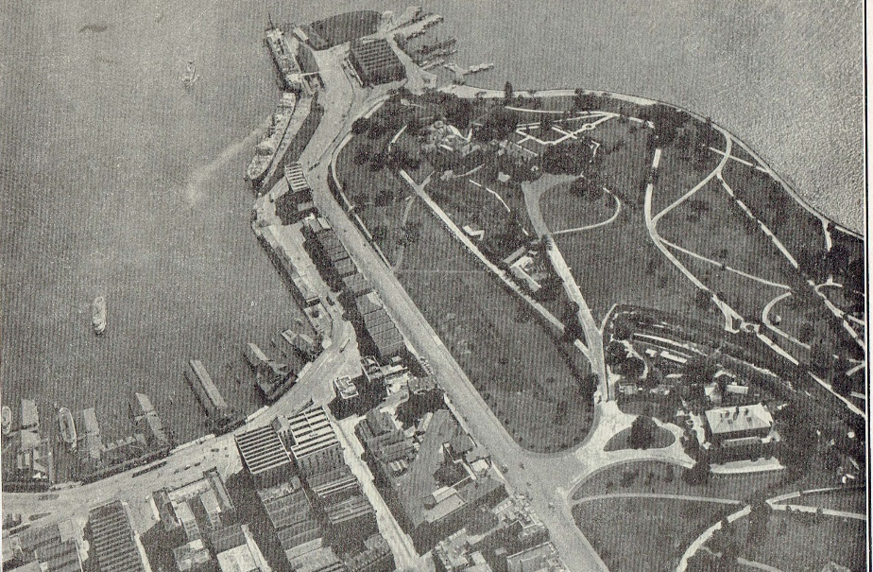
In the evening the airmen were guests of honour at a banquet hosted by the directors of the Sun newspaper; Ross gave a similar speech, praising the contribution of Bennett and Shiers. Sydney’s welcome was overpowering, and he thanked them ‘from the bottoms of their hearts’ for the welcome.
Circular Quay, Bennelong Point and the Botanic Gardens.
Film of the arrival was on view at the Haymarket theatre that evening. Castrol oil was conducting a big advertising campaign, proclaiming that the aircraft had used their oil throughout, and the airmen had ordered a stockpile of 150 gallons for their Sydney stopover. The Kodak salon in George Street advertised Hurley’s photographs. On Monday 16 February the airmen signed innumerable autograph books and visited the Premier and the Governor in the afternoon.

Day 68: 19 February: Mascot to Richmond
The Mascot / Richmond stage is omitted from the summary of the flight listed in 14.000 Miles. This is probably a simple error caused in the haste of getting the book printed and on sale. Exact time details are not available. Distance is 32 miles, 50 km.
They flew to Richmond after an early morning meeting with the Mayor of Mascot. The Ham Common (Richmond) airfield was the home of the NSW Flying School. This was a special project of the Premier, William Holman, and the aircraft was to have maintenance and repairs there. They were then guests for lunch with the Premier and then at a garden party at Belhaven at Bellevue Hill, given by the President of the British Empire League. Here, among a gathering of dignitaries and war heroes, Wally Shiers married his long-term sweetheart Helena Alford. They had intended delaying the wedding, but the onset of Lent meant that it would have to be delayed until Easter, so a quick ceremony was organised! In the evening the airmen were star guests at the Tivoli theatre. The arrival of the Vimy in Sydney, and related events (including the wedding) were featured in newsreel movies shown at the Haymarket Theatre.
This frenetic social activity continued throughout the week. The airmen were generous with their time. There were many articles hailing the flight as a precursor to wonderful developments in civil and military aviation.
On Saturday 22 February many people went to Richmond, hoping to see the Vimy fly, but there was some form of engine problem and the aircraft did not fly.

Day 73: 23 February: Richmond to Cootamundra: (385 km)
The air-minded Premier, William Holman, was carried to his electorate at Cootamundra as a passenger in the Vimy, as had been widely publicised in the press. Take-off was at 10 05 am, and the flight of 240 miles, 380 km took 4 hours 15 minutes. A huge crowd – ‘probably so many thousands of people had never been seen congregated heretofore’ – gathered in the heat and waited for two hours. Instead of coming direct, a roundabout route was followed. Mr Holman explained: They had left Richmond this morning at 10, circled Sydney Harbour, flown down the coast and then inland to Moss Vale, Sutton Forest (over the Governor’s country residence) and Goulburn. They saw the Federal Capital (barely more than a marked-out site) and Burrinjuck Dam and landed at Cootamundra. The Premier was ecstatic. ‘Practically, I have been over the South East corner of the state in an afternoon!’ ‘There is no other transport in the future!’.
The aviators were welcomed with the customary speeches. In his response, Ross paid tribute to the enthusiasm of the Premier, and said that the Richmond airfield had greater potential than any other place in the world

Day 74: 24 February: Cootamundra to Henty: (130 km)
On Monday 24 February take-off was at 10 am. The intention was to fly directly to Melbourne, but there were three forced landings. Details of these are hard to come by: Ross and Keith were keen to minimise news of their aircraft’s failures.
The first landing was near Wagga Wagga, at Bon Accord. Then near The Rock they were on the ground about an hour. The take-off was apparently rather frightening, with the undercarriage grazing the treetops. A plan to fly over Kosciusko was abandoned, and the aircraft headed south. Another problem occurred as the aircraft approached Henty, and Ross made an emergency landing in a field a mile from Henty. The mechanics repaired the aircraft, but too late to continue. The whole population of Henty came to see the aircraft. The word spread to neighbouring towns and carloads of people came from as far away as Wagga to see the aircraft. Welcoming speeches could not be avoided even in these circumstances. At the Rock, the airmen were welcomed by Mr Alam, and at Henty, the speaker was Councillor J H Balfour, President of the Culcairn Shire. The airmen, however, declined the offer of an evening reception that was made by the local Returned Services League, needing an early night!
Schools en route had actually been given a day off to watch the aircraft pass overhead.
Waiting crowds in Melbourne, notably at Flemington, were disappointed at hearing that the aircraft would not arrive. The Age was scathing about the authorities’ communication and care for the waiting crowds, but there was a consolation prize. Shortly after 2 o'clock an escort of six aeroplanes arrived from Laverton under the charge of Captain H N Wrigley, DFC, who was flying a BE2E. Major R S Brown, AFC and Warrant Officer Murphy, DFC flew Avros; Captain A T Cole, MC, DFC, flew a Bristol Scout; Captain A M Jones, MC, DFC and Captain F W F Lukis flew Sopwith Scouts. Colonel Richard Williams, OBE, DSO, and Captain W J Stutt also flew with the escort from Laverton. Colonel Williams was commander of the 1st Squadron Australian Flying Corps, in which Sir Ross Smith was a pilot, and went on to lead the RAAF. They gave a spectacular aerobatic display, ‘without the slightest hitch of any kind’. They landed at Flemington and flew back to Point Cook without incident.

Day 75: 25 February: Henty to Melbourne: (350 km)
14.000 Miles gives take-off time at 6am, distance as 220 miles, (380 km) and flight time as 3 hours 5 minutes.
The airmen dropped an envelope, addressed to the Mayor of Albury, thanking the people of New South Wales for their welcome and help. The envelope had, as well as the address, a note ‘if this hits you on the head, beg pardon’!
In Melbourne, people were watching the sky eagerly from about 10 am, but the arrival in Melbourne was less spectacular than occurred in Sydney. The aircraft was met at Broadmeadows by a Bristol Scout flown by Captain A F Cole, and a Sopwith flown by Captain F W Lucas. After a flight over Melbourne they landed at Point Cook, 25 kilometres away, not at Flemington in central Melbourne. They were greeted by Colonel case, the commander, and Mr H J Berriman, Major W H Anderson and Captain Wrigley (page 29). Many people came to look at the machine and to greet the airmen.
Ross’ speech included an apology to the people for not arriving the previous day. He explained the problems they had encountered and rated the take-off at The Rock as the most dangerous on the whole trip. In the final leg to Melbourne, they flew on only one engine. Ground mist meant that they had difficulty locating Melbourne, and they had to remain at an altitude of 7,000 feet (possibly also because this would give some safety in the event of the second engine having problems). They wanted to fly on to Adelaide, but their aircraft would require major work before this could be done.
Among the people meeting the flight were the very proud parents of Jim Bennett, with his three sisters. The family lived at St Kilda, and the council was preparing a major welcoming event for him.

Melbourne, 26 February to 21 March
As in Sydney, the airmen were hugely popular. Even on the first night they were guests of honour at a theatre production, and their every move was chronicled. A display of souvenirs at the Kodak shop was very popular, including a Kewpie doll which was a mascot. They were lent a Crossley car for their use while in Melbourne. They were deluged with good wishes, offers of paid lecture tours, and even marriage proposals, which they politely declined!
Melbourne was the acting national capital, pending the construction of Canberra. The Prime Minister, ‘Billy’ Hughes was keen to join the celebrations, and on Friday 27 February the £10,000 cheque was presented at the Victorian Parliament House, Melbourne, the temporary premises of the Federal Government.
The airmen were greeted by a cheering crowd, were presented with the cheque in the Prime Minister’s office, and then were guests at an official luncheon.
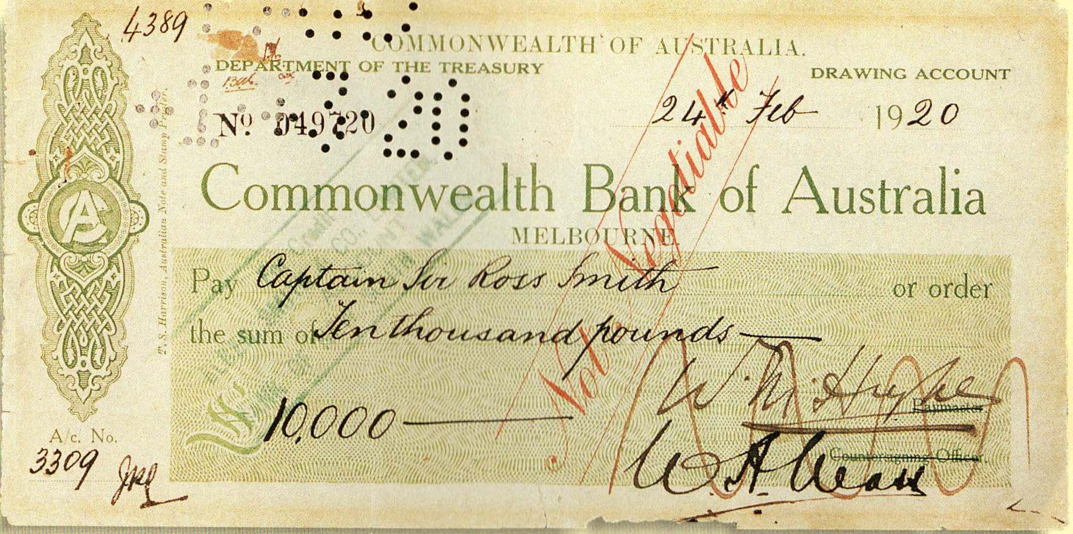The plan was to fly on to Adelaide within a week. It was proposed that the Vimy might be brought to Flemington to go on public display, but the airmen wanted good security for the machine, which had previously been written on and even had people’s names scratched into the fabric with pocket knives.
The airmen continued their busy schedule of social engagements, and the newspapers ran many aviaton-related and background articles. Bennett and Shiers were given military promotions: there had been some newspaper articles that inferred that their contributions had not been given the recognition that they deserved.
The machine, however, remained at Point Cook while being repaired by Point Cook mechanics, and the first test flight actually occurred on 15 March. There had been a lot of ‘behind the scenes’ activity: Ross wanted to fly to Adelaide, his home town, but others, including some people from Vickers, were concerned at the state of the machine and would have been happier if the flight had been ended at Melbourne.
In the end the aircraft was fully overhauled. On Friday 19 March the aircraft made its long-delayed flight over Melbourne, and on behalf of Vickers Ross presented the machine to the Commonwealth of Australia. The agreement was that the aircraft would fly to Adelaide, then be given to the new war museum that was being established.

Day 102: 23 March: Melbourne to Adelaide: (690 km)
The aircraft took off from Point Cook at 7 am, with an early escort of Point Cook machines. The whole event was described in glowing tones in a full front-page of the Melbourne Herald. As well as the usual paraphernalia such as the Kewpie doll mascot and the various letters from dignitaries, they carried pigeons, to be set free over Ballarat to bring back news to the Herald. Basically, the flight of 430 miles, 700 km, was as planned.
The aircraft followed the railway lines, taking it over many townships, all of which came to a standstill to watch the aircraft fly into history. It was the first to fly direct from Melbourne to Adelaide. At 2 30 pm exactly it landed at Northfield, where a crowd of over 20,000 cheering spectators welcomed the airmen.
A brief extract from the Adelaide Register report gives a flavour of the reception:
The City's Greeting.— Flags flew joyously in the pleasant breeze …Business was practically at a standstill, and never were the proprietors more indifferent. For the half-hour prior to the arrival the city was practically deaf to everything but that which concerned the coming aeroplane. … Minute followed minute, almost breathlessly, as the hour of 2 approached, and it was known that much time had been 'made' 'by the powerful machine.
Suddenly, when tension was at straining point, the Town Hall bells rang out blithely, factory whistles joined in a medley of joyful greetings, people cheered and shouted with one thought in common. The great moment had arrived. The heroes were here.
The Arrival.— Sometimes we see a cloud that's dragonish, a vapour, sometime like a bear, or lion, a tower'd citadel, a pendant rock. All of these illusions might have fitted the hazy speck which suddenly rewarded many minutes of anxious scrutiny, and was greeted with a chorus of varied greetings from street and air, for the various buildings were 'decorated' with crowds of people, who resembled ants when viewed from the ground.
The aerial 'ant' gradually assumed form as field glasses anticipated the arrival. [From Glenelg airfield Captain Moore … with Brigadier-General Antill (State Commandant) on board, [in a DH-6] and Lieut. Miller,[in a Sopwith] … formed a winged guard of honour to escort the famous visitor with its 'home-comers' on board. …. Suddenly, at 1.35, guns boomed out successively, whistles screamed their exultant notes, the bells at the Town Hall rang happily, and the last link on the British-Australian journey had been forged.
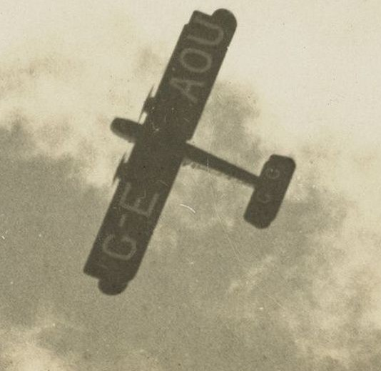
Out of the white misty line formed by the sentinel clouds on Mount Lofty and the adjacent peaks, the monster gradually emerged from nebulous form in the gully to the left of Mount Lofty, and assumed the graceful aspect of a soaring bird.
The town clock boomed out the chimes of the last quarter before 2, and Sir Ross Smith and party were then well in sight. Without haste, the Vickers-Vimy performed a manoeuvre which brought it, escorted on either side by the local 'planes, in the form of a huge V, over the city at 1.33 p.m.
Captain Butler's absence caused various conjectures, but he arrived in time for the landing, and 'looped the loop' in celebration of it. It transpired that he had travelled to the Murray to meet the party, and had missed his bearings in the clouds. …
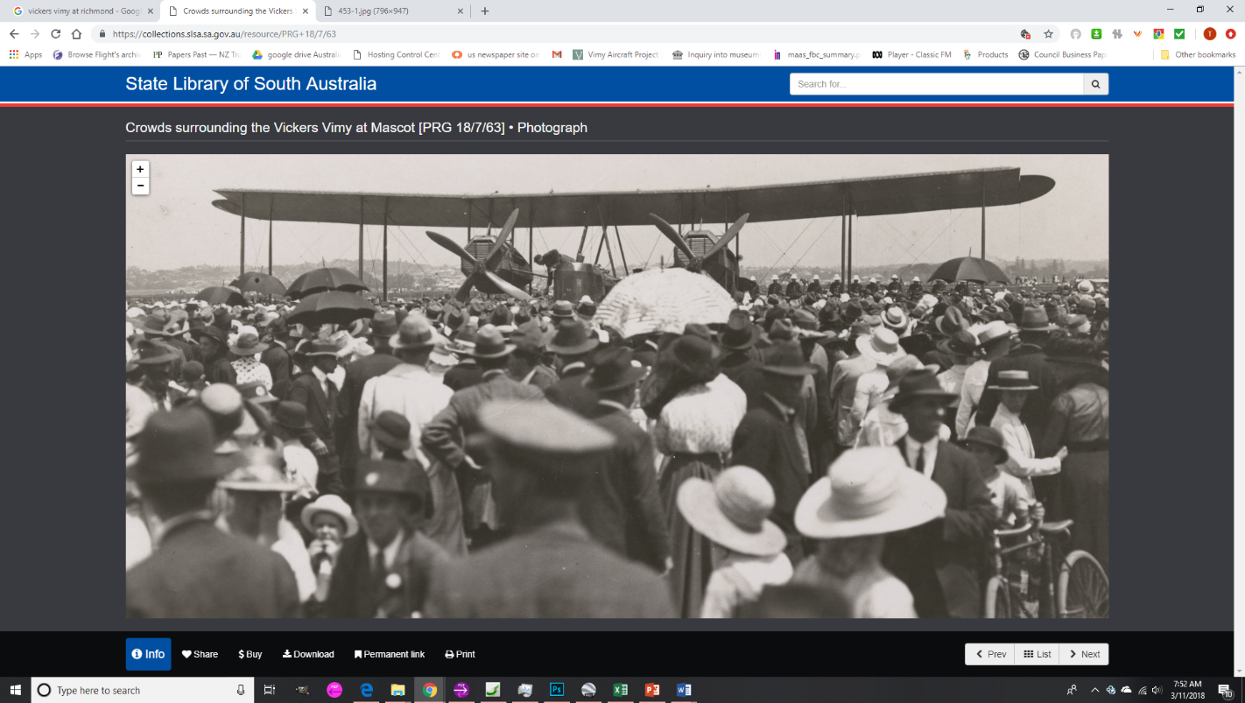
—The Final Lap.— The opalescent colours of the sky formed a lovely 'background' for the travelling aeroplane, with its brown-and-gold shades. As it turned gracefully about, emitting a humming sound, it resembled a giant wasp. … The aeroplane also 'visited' the emporium of Messrs G P Harris, Scarfe & Co. [Ross had worked there before he joined the armed services].
—At the Aerodrome.— As soon as the giant machine touched earth the crowd, which numbered more than 20,000, broke through the cordons of police and soldiers and rushed pellmell towards the aviators. They cheered and shouted until they were hoarse. Never has anything more impressive or exciting been witnessed in Adelaide. Hundreds of people exposed themselves to danger in their attempt to pay homage to the gallant crew.
For some time after the 'plane had come to a standstill Sir Ross Smith and Sir Keith Smith refused to leave their seats. They explained that they feared the crowd might do damage to their machine. Time and again efforts were made to push the people back, but every endeavour failed. At last at the special request of the Premier the two Knights alighted. Once more the cheering became tremendous.
The brothers were seized by soldiers and carried shoulder high through the still shouting multitude. The two mechanics remained in charge of the machine.
(Photograph from the SA History Hub website)

The later stories
For reasons of length, this short account must end here. But in brief:
Ross and Keith Smith became more involved with Vickers aircraft. Ross Smith and Jim Bennett, recently promoted to Lieutenant, were killed in the crash of a Vickers Viking amphibian at Brooklands, UK, 3 April 1922. The same aircraft type eventually also killed John Alcock, famous for flying another Vimy across the Atlantic in June 1919.
Keith Smith maintained his association with Vickers, but the relationship was not always happy. Basically, the early Vickers aircraft were not of high quality. QANTAS tested the Vickers Vulcan single-engined airliner in 1922, but it was so underpowered that in the hot Australian conditions it could not carry more than half of its designed payload. Vickers established many non-aviation ventures in Australia, but not always involving Keith.
In 1938 two Vickers Wellesley long-range military aircraft flew from Ismailia, Egypt non-stop to Darwin, to Australia, establishing a long-distance flight record (7,162 miles, 11,460 km) and improving Vickers’ image. Keith was by then involved in a wide range of activities including Cockatoo Naval Dockyard, and was involved with Vickers products such as the ocean liners Orsova and Orcades. At last, in the early 1950s, Vickers produced the Vickers Viscount turbo-prop airliner, a great success in Australia. Keith died in 1954.
After a brief venture as a garage owner Wally Shiers returned to aviation in partnership with pilot Dave Smith (no relation!) in barnstorming and other activities, flying a Ryan monoplane. He later became chief engineer for New England Airways. He was the only survivor of the original crew at opening of the Adelaide display building for the Vimy in 1958 and died in 1968.
Frank Hurley continued his successful career as writer and explorer and was war photographer in the second world war. He died in 1965.
The Vimy was placed on display around the major capital cities, then put into storage until the construction of the Australian War Museum in Canberra where it was part of the display from the opening of the museum on Remembrance Day 1941. It was removed in 1955 – a reason given was that it was not a relic of the war as such – and while being moved to Adelaide in 1957 it was damaged by fire.
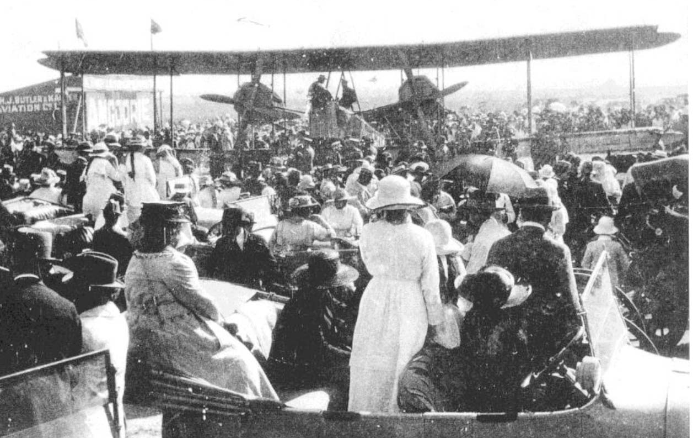
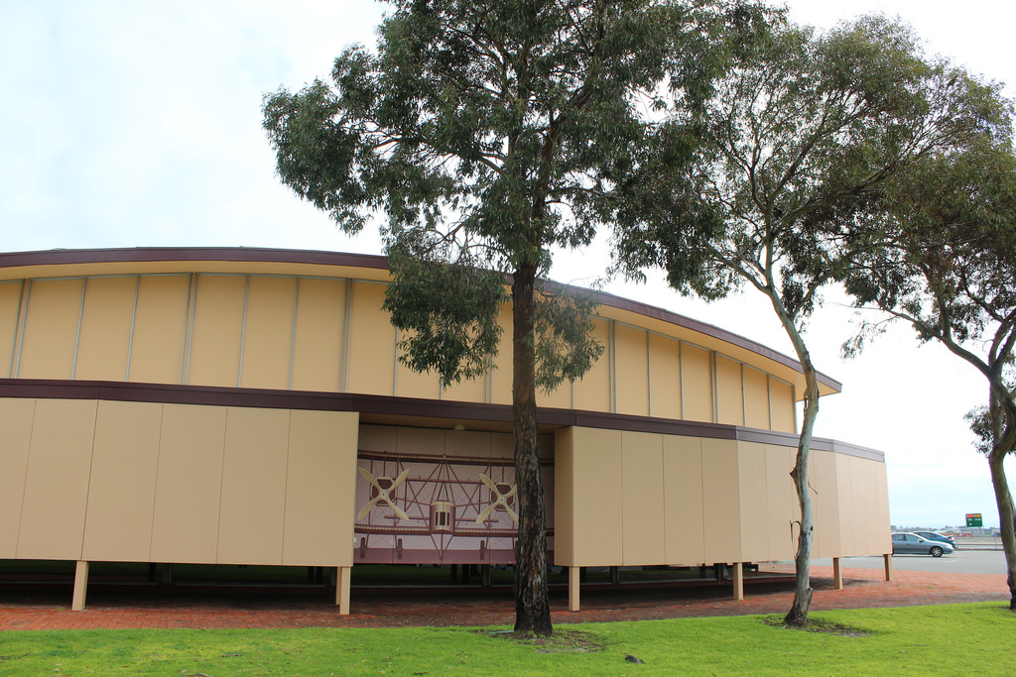
The Vimy was properly restored; in 1958 it was installed in a specially built display hangar at Adelaide airport. As the airport has expanded over the past 60 years it has become rather isolated. The glass front has been altered to prevent degradation of the aircraft by light. The opportunity is being taken to try to improve the situation: ideally, as a result of centenary commemorations, the aircraft will be a centrepiece of the new Adelaide airport terminal.
The scene at Northolt, Adelaide, 23 March, in front of the hangar of pioneers Harry Butler and Harry Kauper,

Appendices
These aviators performed mighty feats, but others played important parts in their successful trans-Australia flight. This section mentions some of them and briefly mentions other aspects of the flight and its commemorations.

Appendix 1: the ‘Aerial Services’ expedition, 1919
In January 1919, businessman Reginald Lloyd proclaimed his newly formed company, Aerial Services Ltd, with plans to commence an aerial service from Britain to Australia.
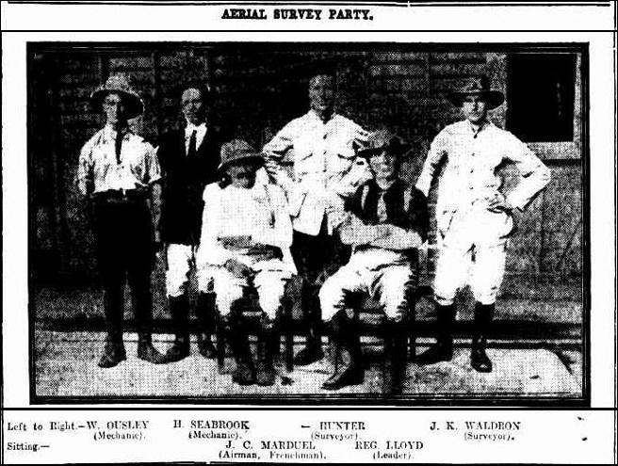
On January 31, 1919, with considerable publicity, four Indian motor cycles with sidecars, carrying seven men left the home of Reginald Lloyd’s uncle, in Five Dock, Sydney. The aim was to survey the Australian section of the route, placing airfields every 300 miles.
Jean Marduel was the expedition’s ‘aviation expert’. After the early pioneering work outlined on page 28, Marduel had a less than successful stint as a non-commissioned officer in Egypt (he was badly affected by heat and was hospitalized most of the time) he returned to Australia and became an instructor at Point Cook. As more experienced people returned from the war, he left Point Cook, and this was his first post-war venture into aviation.
After being injured in a motorbike accident near Roma, he struggled on to Camooweal. Here he became ill and returned to Sydney. The survey was completed by August 2, 1919 by other members of the team. It was a mighty feat of motorcycling, but the ambitious airline plan never eventuated.
AHSA historian John Scott has researched Aerial Services Limited, and the survey expedition. He points out that the route used by Ross and Keith Smith in 1919 was largely the route surveyed by the Lloyd / Marduel expedition. This route had almost certainly been suggested by Dr Griffith Taylor, University of Melbourne meteorologist, who had lectured at Point Cook at the time that Marduel was there.

Appendix 2: Fysh, McGinness; the air race and QANTAS
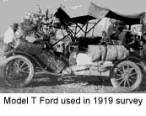
Tasmanian Hudson Fysh was a member of the Light Horse and, like Ross Smith, a veteran of Gallipoli. He later became a pilot, involved in fighting in the Middle East. He was well-connected, from a well-to-do family. With wartime companion P J McGinness, he had hoped to enter the great air race in 1919 but their backer, Sir Samuel McCaughey, died and the project lapsed. They were then offered the task of preparing a route from Longreach to Darwin, via Normanton and the Gulf of Carpentaria.
Until Burketown this was a relatively simple journey. Their specially modified Model T Ford, carrying 47 gallons of fuel, set off across an area never previously traversed. Over 10 major makeshift repairs were needed, and they averaged only 16 miles a day in the journey to Borroloola. From there they struggled on to the railway at Katherine. In Darwin, Fysh was put in charge of preparing the airstrip, while McGinness travelled back to Cloncurry, checking airstrips on the southern route that was actually used and finally welcoming the Smiths to Cloncurry (page 28). Fysh remained in Darwin to prepare the Fannie Bay airstrip.
Fysh and McGinness were shortly afterwards involved in the establishment of QANTAS, originally Queensland and Northern Territory Aerial Services. The main early route (Charleville to Cloncurry) is shown by the thick black line on the map and the red line shows the remarkable motor vehicle journey.
The map is adapted from Hudson Fysh’s QANTAS RISING.
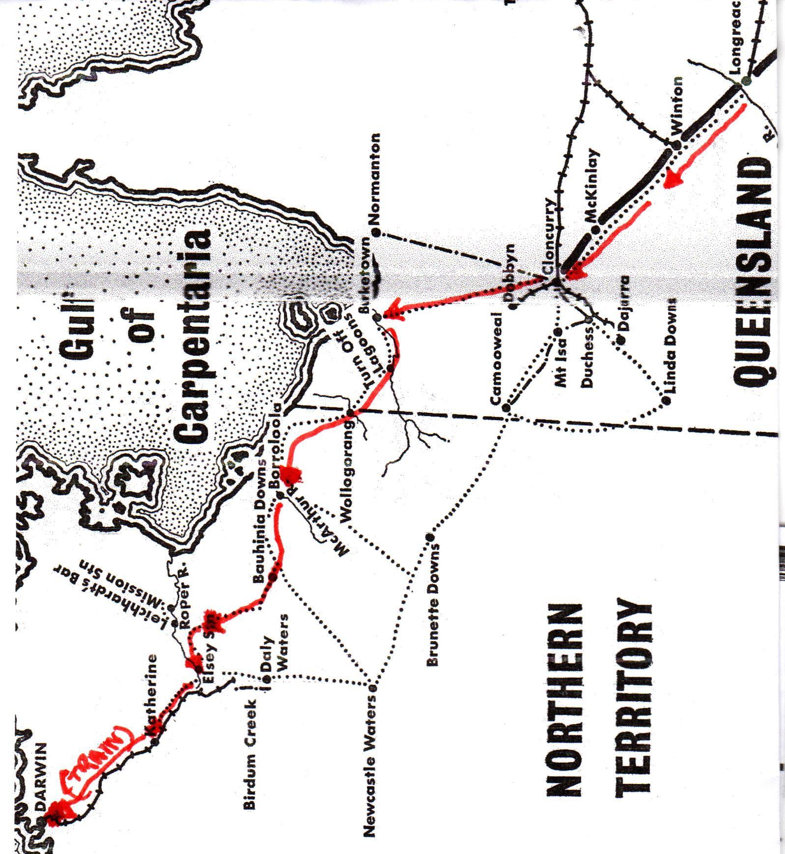

Appendix 3: Wrigley and Murphy: first flight across Australia
Captain Henry Wrigley was an Australian pilot who served with 3 Squadron in 1917-18, being awarded a DFC. With Sergeant A W Murphy he began a flight to Darwin as reconnaissance for the participants in the England / Australia. Their aircraft was a BE2 of pre-war design. Making the first transcontinental flight in Australia in only 28 days, with such an old machine, was a wonderful achievement. The itinerary was as follows:
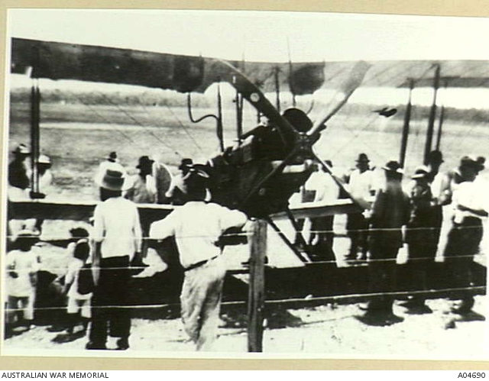
16 November: Melbourne to Cootamundra; 17 November: Cootamundra to Forbes; 18 November: Forbes to Narromine, forced landing at Wyanger (?), en route; 19 November: Narromine to Maclean (where they were delayed a day with engine trouble); 22 November: Bourke to Barrungun (on the Queensland Border); 23 November: Barrungun to Cunnamulla; 24 November: Cunnamulla to Charleville (another day lost due to engine trouble); 26 November: Charleville to Blackall (with a stop at Tambo); 27 November: Blackall to Longreach ; 28 November: Longreach to Winton; 29 November: Winton to Cloncurry. At Cloncurry the engine was overhauled. 6 December: Left Cloncurry but after 30 miles returned owing to engine trouble. 7 December: Cloncurry to Avon Downs; 8 December: Avon Downs to Alexandria after failing to reach Anthony Lagoon owing to a faulty map. The tailskid shoe was damaged when it struck a rock on landing, the only accident. 9 December: Alexandria to Katherine, and thence to Darwin. (A great effort was needed to cut trees to make an adequate take-off area at Katherine); 12 December: Arrived Darwin.
This was two days after the arrival of the Vickers Vimy, and the Vimy crew greatly appreciated Wrigley’s advice.
The BE2 and its crew returned to Point Cook by ship. The aircraft was overhauled, and in in February 1920 was given to the Australian War Museum.
Henry Wrigley went on to be an Air Commodore, the senior RAAF officer in Britain during World War II. He died in 1987, aged 94.
Picture: Wrigley’s aircraft at Avon Downs. (http://www.adf-gallery.com.au )

Appendix 4: Richmond (Ham Common)
Jean Claude Marduel was born in Lyon, France in November 1877. He migrated to the USA in 1900, married and had a daughter born in 1902. Leaving them behind, he arrived in Australia in May 1908, and became Principal of the Berlitz school of languages in Sydney and also was involved in motorcycles and motoring. This fashionable school was widely advertised.
The French aerobatic pilot Maurice Guillaux arrived in Sydney on 8 April 1914. Guillaux spoke little English, and most probably Marduel’s local knowledge was of assistance to the group. Guillaux taught him to fly.
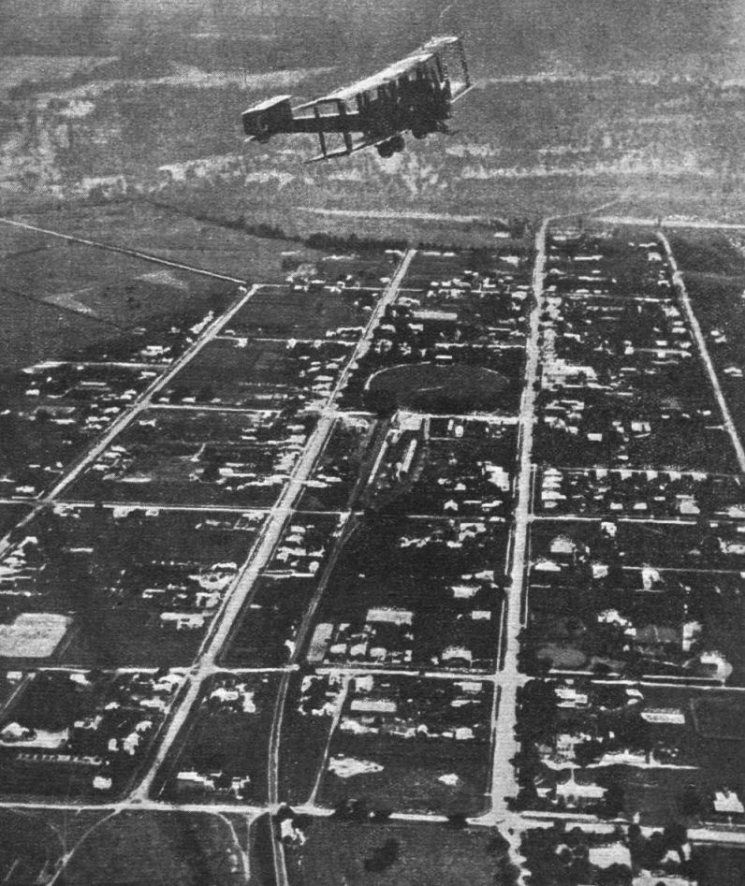
In 1912 the Ham Common (Richmond) area had briefly been used previously by pioneer airman W E Hart. By July 1914, Marduel, as representative of Guillaux, was in Richmond, arranging for the construction of a hangar for a Caudron G III aircraft that was being imported by Guillaux, financed by Sydney businessmen. After Guillaux returned to France in October. The aircraft was used by Marduel, based on Richmond.
Marduel left Richmond, and appears in another context (page 31).
Richmond was taken over by the State Aviation School in 1916. It was from here that William Stutt made many pioneering flights. In 1920 it was the best-equipped airfield in the state, and hence the Vimy was overhauled, and started its journey to Melbourne from Richmond.
The Vickers Vimy leaving Richmond for Cootamundra (page18). Picture from the Russian website http://aviadejavu.ru/
In 1925 Richmond was taken over by the RAAF and remains a major base, largely for transport aircraft.

Appendix 5: The 1969 air race
The Commemorative Air Race, (officially titled the ‘BP England to Australia Commemorative Air Race’), was an Australian Government initiative, and took place between 17 December 1969 and January 2 1970. It was organised by the Royal Aero Clubs of Australia and the UK. British Petroleum (BP) was the main sponsor: other sponsors included Rolls Royce, Qantas, Avis, Dunlop, Shell, Wakefield, Vickers, Ansett, and the Australian Government.
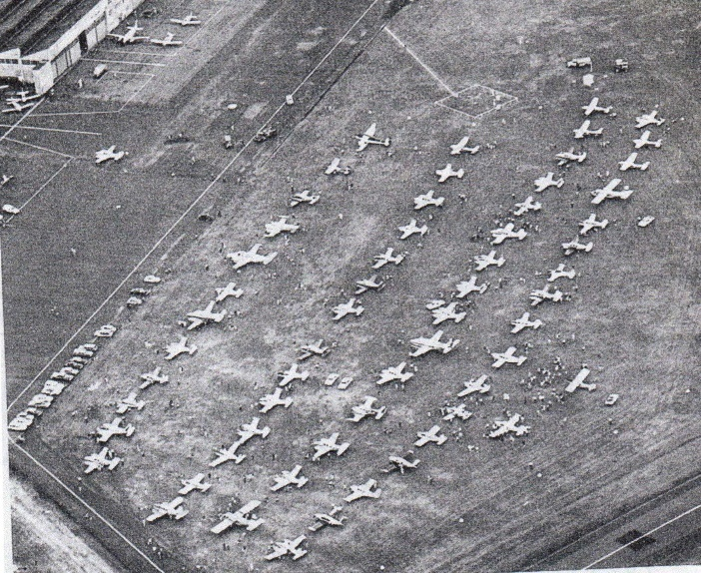
Bankstown airfield, January 1970: the aircraft that completed the event.
There was over $100,000 in prize money, and the event attracted a field of 76 starters, A handicap system was used. The competitors were required to make compulsory control point stops at: Athens, Karachi, Singapore, Darwin, Alice Springs, Adelaide, and eventually Sydney, and to reach Adelaide by 28 December, then to Sydney on January 2. 56 aircraft reached Sydney, and there were some other unofficial starters including a Hawker Siddeley HS125, representing Qantas Airlines.
Details of starters and winners lists are on www.lockoweb.com/smith , but the event, run with complete safety, was mainly important for demonstrating the enormous advances in aircraft use over the fifty years. It was a great event; the tradition is being continued in 2019 with an electric aircraft race being supported by the Northern Territory government.
This summary of the 1969 event comes largely from the website for the 2019 event, https://www.greatairrace.com.au/ . It is hoped that the 2019 event will also include provision for wide involvement, notably from Darwin to Adelaide.

Appendix 6: Lang Kidby and the 1994 re-enactment
Lang Kidby, an Australian adventurer, and Peter McMillan, a wealthy American, began the construction of a Vimy replica early in 1993. They assembled a wide range of sponsors and their aircraft first flew on July 30, 1994. As the table overleaf shows, its specifications were as close as possible to the original: enormous care was taken to be as accurate as possible, even covering the aircraft with cotton canvas rather than synthetics.
The only major variations were the substitution of modified Chevrolet auto engines for the Rolls Royce Eagles.
According to the Britain to Darwin itineraries in The Greatest Flight, the1919 flight took a total of 29 days, with 135 hours 55 minutes of flying time. It visited 23 airports en route, covering 1160 miles.
The 1994 flight took a total of 42 days, with 148 hours 35 minutes of flying time, covering 11,256 miles. The details are on the website.
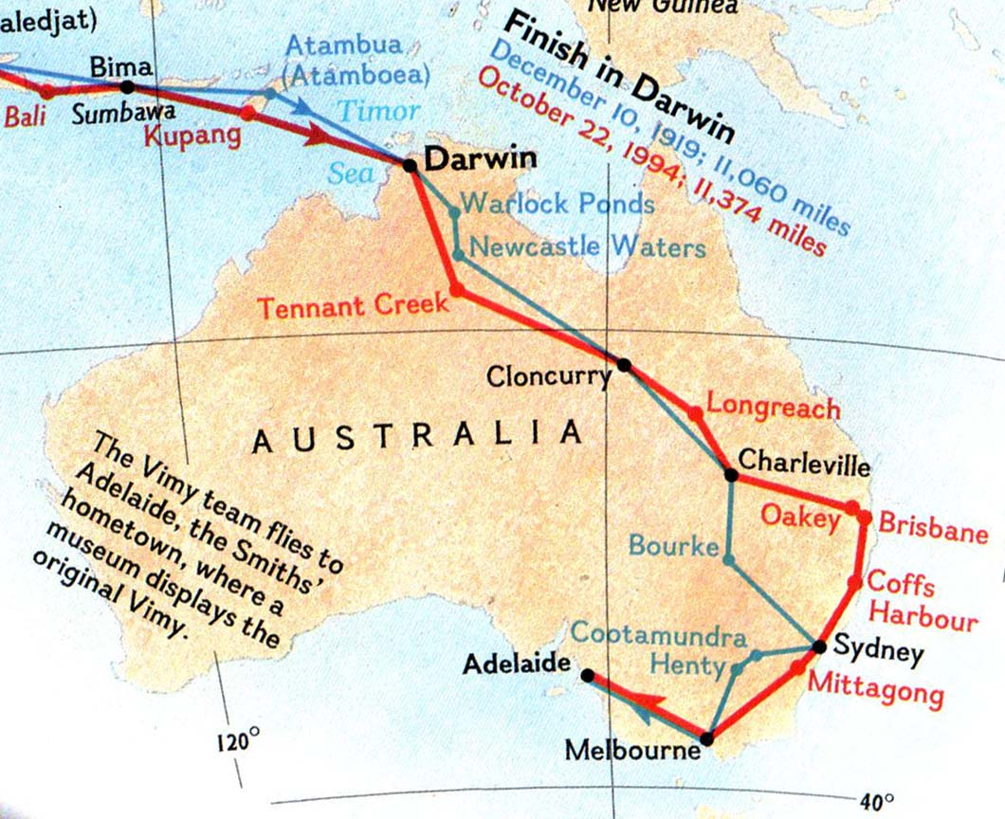 .
Here, we are concerned with the Australian section of the flight.
The map shows that the 1994 itinerary (red line) had some differences from that followed in 1919 (red line).
Kidby arrived in Adelaide on November 11, 1994, 20 days after reaching Darwin, being delayed en route by welcoming ceremonies and speeches, as had happened in 1919!

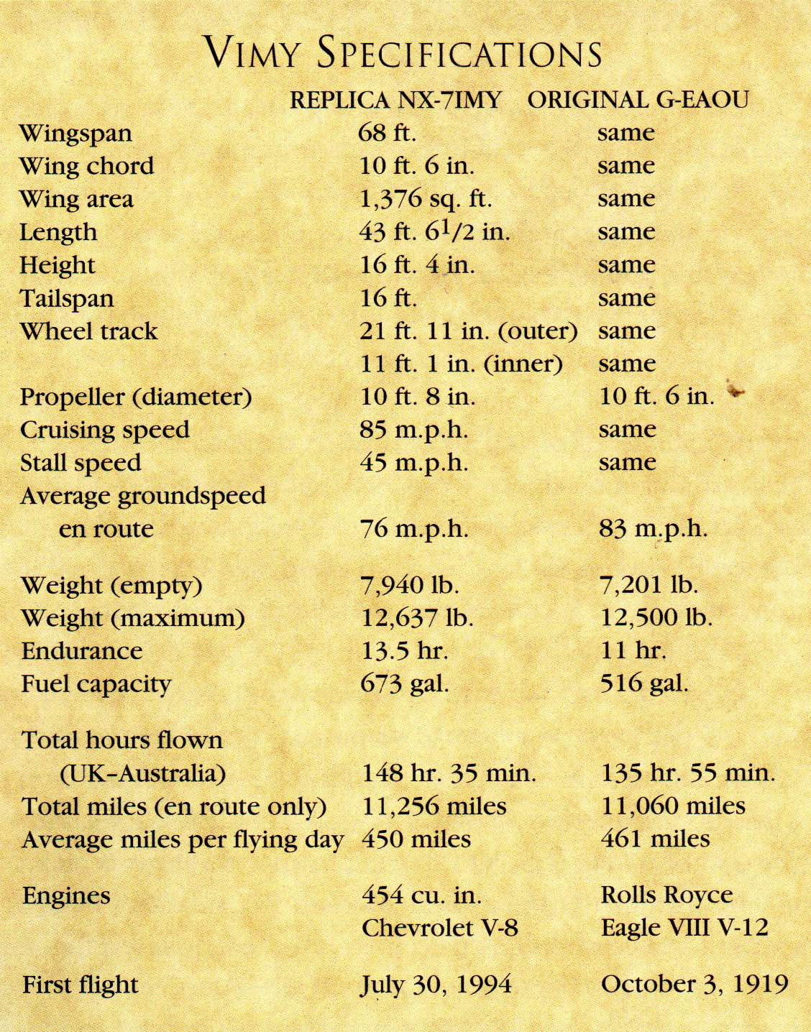

Appendix 7: Philately
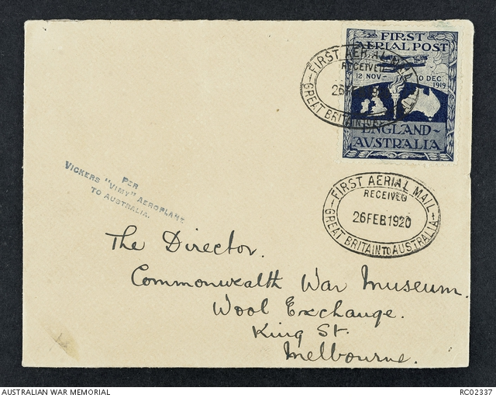
This envelope demonstrates the three-line cachet stamp applied by the Smiths and the government-produced sticker, known to philatelists as a ‘Cinderella”..
In the first part of the 1919 flight, the Vimy carried a few letters from England. Similarly, Poulet and some of the other unsuccessful entrants carried mail. These are rarely sold: a 2013 sale of one of the Vimy letters realised $3500.
When the Smiths reached Australia the federal government commissioned a design for a special sticker, prepared by war artist Geoffrey Benson. 576 were printed, 125 destroyed, leaving 451. 364 were actually used on envelopes, leaving 87 in mint condition. Many are held by the government, but a perfect specimen with selvage all around is among the most valuable non-stamp piece of paper in on the philatelic market, and would sell for $30,000+.
There were commemorative ’cover’ issues to mark the tenth, twentieth, fortieth, fiftieth, sixtieth, seventieth and seventy-fifth anniversary of the flight. Of these, the biggest was for the fiftieth anniversary, linked in with the air race (page 32). Indeed, philatelists, led by Nelson Eustis and Ernest Crome, chartered a DC-3 to fly to Singapore and back. Reg Williams, the only surviving participant in the 1919 race, was a passenger.
The Australian Air Mail Society also produced a special souvenir sheet.
The Vimy figures in an issue of 5c stamps that were also issued to mark the fiftieth anniversary of the flight. 45c stamps were also issued on 29 August 1994 as part of an aeronautic set also featuring Lawrence Hargrave. There was also interest from other countries. Stamps commemorating the flight were issued by Monaco and by Indonesia.
There have been several other issues commemorating the Vimy, notably on 5 March 1988.
Many examples of these can be seen on www.locklweb.com/smith.
Australia Post is making a special stamp issue, and the Commonwealth Mint is making a special coin issue to mark the 2019 centenary.
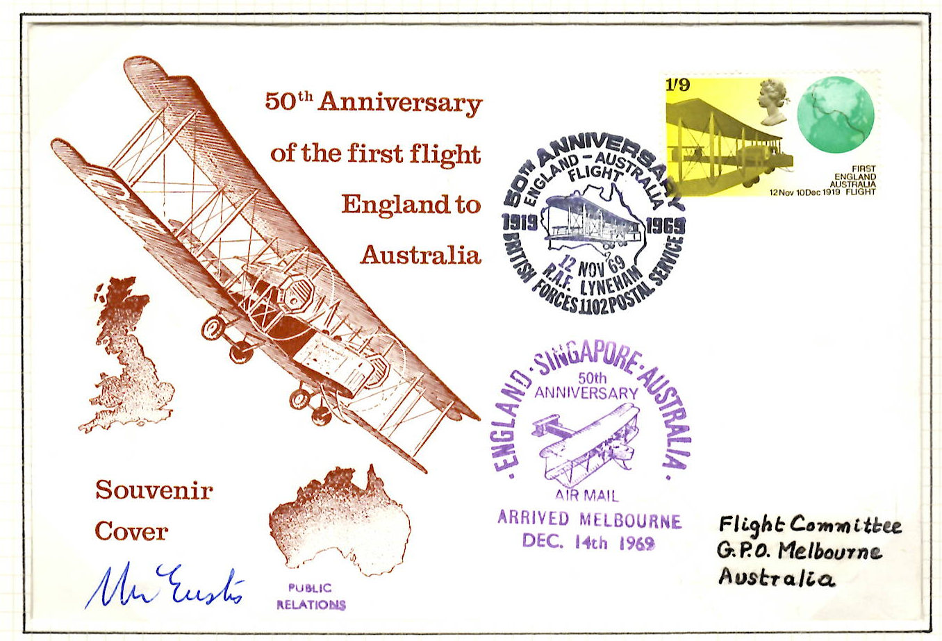
Left: commemorative ‘cover’ signed by Nelson Eustis, philatelist and historian, 1969; Below: ‘cover’ carried by Lang Kidby in Vimy replica, 1994.
